The Unintentional Nudist XII: "Tami Smithers Was Here",
by DonnyLaja

Part 38

This chapter was written by Leviticus, and let me extend my thanks to him. Contributions to this saga are always welcome!
--donnylaja

It was green and it had a Cleveland Indians logo on the front, and it was just hanging there on a wooden post in the middle of nowhere. Its brim looked like it had been chewed on by a dog and strange stains colored one side of it, but to the naked girl hiding in the bushes it had a very special fascination.
Tami Smithers had been walking for a while, following a dirt path through a forest, trying her best to keep going east although she felt a little lost at this point. It was as she was walking that she spotted the hat hanging from the top of a rotted post and she immediately hid behind some bushes.
Where there were clothes, there were people, or at least that was how it seemed to Tami lately. Several times over the last few weeks she had come across seemingly abandoned bits of clothing, only to have something happen to it before she could claim it herself. She had grown cautious, gun shy if you will, of apparent presents from the Gods.
But she had been watching this old baseball cap for maybe an hour, or so she estimated, she hadn't worn a watch for a year either, and no one seemed to be around. In fact, she hadn't seen a soul all day which suited her fine.
The hat was there for the taking. The naked girl crept out of her cover and walked the last few yards along the path to her target. She reached out and tentatively touched the brim of the hat, fearful of any booby traps. But it was just an old, worn hat.
She picked it up and savored the feel of the material in her hands, its warmth, its texture, and she carefully looked around once more just to see if she was being observed. Too many times in the past clothing had been dangled in front of her out of her reach, or pulled away just as she was reaching out to grasp it. But not this time, now she had the hat in her hand and she was keeping it.
Most people would have put a hat on their head, but Tami instead held it in front of her crotch. She imagined herself covered down there at last, prying eyes unable to see her sex, and the image was nice, but she knew she couldn't walk around holding the hat there all the time. Out of curiosity she held it up to a bare breast, cupping it like a bra would, and she grinned at the feeling of the material against her soft skin. That too was nice, but she would need two hats for it to be any good. So she popped it on her head.
The hat was big for her, and wasn't adjustable, but Tami really didn't mind. She had clothes. True, it was an old hat that was pretty useless as far as covering her nakedness was concerned, but it was still clothing and she loved it.
Her spirits raised, she continued on down the path.
She walked for a long time, sleeping when she was tired, eating when she was hungry, and the countryside changed a little over the miles she traveled. At one point she found the path skirting the edge of a series of ploughed fields, and there was a road on the other side of the fields she had to be careful of. It didn't seem to be a well traveled road though, and as she walked on she saw why. There was a large group of men in orange jump suits working the ditches, and Tami knew right away that she was looking at a chain gang. From her perch within the trees she watched them for a moment, very scared that they might see her. She imagined their reaction to seeing a naked girl going by, some of them probably hadn't had a woman in years! She imagined being caught by them and taken back to their prison, hidden away under a blanket perhaps, then kept for the amusement of the prisoners. Even the guards would be in on it, not letting her go until she serviced them as well.
Tami's active imagination, fueled by too many prison flicks watched as a child, concocted horrors that got her moving again, and she snuck by without being seen. The trouble was those images had gotten her feeling horny again, and she hated what McMasters had done to her. There were times she felt like a slut, but she looked around for a handy stick anyway.
If she HAD stuck around though and looked a little closer, she might have noticed that the people with the "prisoners" were not guards, but a film crew shooting a commercial. The director of this commercial was pissed because his leading lady was throwing a fit back in her trailer. "DAMMIT!" he yelled after yet another hour was wasted. "I swear, the next woman I see I'll just slap into costume and film instead! Especially if she is good looking!"
His assistant snorted. "Yeah, and where are you going to find one of those out here?"
"Too true, too true. Come on, let's go see if they have picked out all the green M&M's from Her Majesty's bowl yet!"
Unhearing, Tami kept walking.
The path wound down into a valley and soon started following a river. It was a fast moving river and it flowed over a rocky bed. For several miles it had carved a deep channel and the path pretty much petered out. But Tami decided to keep going, a little more confident now that she had her hat, and she scrambled over the rocks like a mountain goat, her lithe nude body making quite a picture.
But it was also quite windy between the steep sides of the river valley, and sure enough a gust of wind caught what was left of the brim of her hat and took it off her head. The hat blew away and landed in some rocks closer to the river surface.
Tami stopped and looked back. She seemed frozen, staring at the scrap of green material fifty feet away. She knew that the hat really didn't cover her at all, that as clothing it was pretty useless. But after a year without anything it was the only clothing she had and she was not going to leave it behind. So she turned around and started to climb down after it, stepping gingerly across the boulders that littered the valley floor.
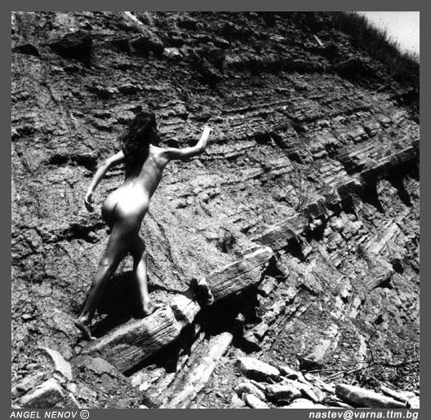
The wind was still blowing though and it seemed that just as she was getting close a gust of wind would take the hat away from her again. Tami began to cry with frustration, fixated on getting her hat back. It had become a symbol for her for everything she had lost over the past year. Her life, her future, was in her mind tied up in getting that hat back. So she struggled and cursed, scraping and bruising herself as she followed along. Soon she was beside the river itself, walking slowly across the rocky shoreline for as tough as her feet had become, the sharp rocks were tougher and walking was painful.
But the wind was cruel that day and as she reached once more for the hat it was blown into the fast moving water.
Again Tami stopped, only this time it was to watch her hat being swept away down river. It was moving so fast she would never catch it and she knew it was lost forever.
She sank to her knees, ignoring the pain of the sharp rocks, and she wept at her loss. For a time she had something to wear, even though it was only a wretched old hat with a chewed up brim and ugly stains, but it was hers!
After a while she picked herself up and morosely continued on her way, but if anyone had been watching her they might have wondered what could have driven this naked girl to the point where losing an old hat caused such sorrow.
If only they knew.

The Unintentional Nudist XII: "Tami Smithers Was Here", Part 39

She looked carefully at the dim shadow on the top of the truck body below, the shadow of her crouched form thrown by the little streetlight some distance behind her. It would be a jump of about eight feet, easy to make. Nobody would hear her; the sound of the idling engines was too deafening. This was a big truck stop, filled with snoozing truckers and idling trucks at roughly (she guessed) about three o'clock in the morning. She had her eye on the flatbed over there, the one with the big upright concrete cylinders, that would probably would end up as a water main.
The naked girl jumped, landing expertly and softly with hands and feet thumping at the same time onto the dirty metal. Not that loud a thump. She looked back up at the overpass, part of the ramp from the interstate. She had done this so many times, a naked ghost lurking and hopping through this nighttime shadow world of truckstops. Now she looked over at the truck with the cylinders, and began planning how to get from here to there.
What! The truck lurched under her. She fell forward, stopping herself by putting her hand down. It turned out this trucker wasn't asleep like the others. She frantically looked around but there was no safe place to hop off. As the truck shifted with a jolt out of crawling gear and huffed under the overpass she ducked, even though there was plenty of clearance.
In a minute Tami was riding naked on top of the truck trailer, booming down the interstate at 65 mph. To keep from getting knocked off by the stiff blowby she had no choice but to fall flat on her tummy on the cold dirty metal, hands grabbing over the front lip. What made it even worse was she was going the wrong way. The concrete cylinder truck had come from the south and would be going north. But this truck was heading south. From South Carolina!
She closed her eyes as the wind caused tears to run down and immediately evaporate before they could make it halfway down her cheeks. She felt the wind whistling over her butt cheeks, around her breasts, past her heels and toes. It was cold, there was a terrific wind chill even though the temperature was not low. Her hair flew back wildly. She looked ahead whenever she could, making things out through her teary eyes. She prayed, her big fear being that her head would slam against a low-clearance bridge. Fortunately there seemed little danger of that, as she realized that there were trucks going by with higher bodies. Truckers must know this highway well and would not travel on it if the bridges were too low.
Also it was fortunate that no one could see her. She remembered once again that the police were on the lookout for her, or so she had to assume. Now that she knew Sarah Wickland could be trusted, she wished she had sounded her out about that instead of staying mum.
And now the flash of lightning and it began to rain. It was an icy shower of needle-like bullets that stung her from her arms down to her calves, making the truck metal feel warm by comparison. "P - please God . . ." She felt in real danger now, from hypothermia. And there was no escape. She felt the slickness under her crushed breasts and her shivering thighs and her hands clamped onto the front lip with an iron grip. To slip or let go would mean certain death. She had to pee and just let it go, no doubt it mixed with the rain and simply washed off the back of the truck.
She turned her head to see the sunrise. The clouds were passing and had let the sun through. Soon the rain stopped. She wondered who could see her now. Who ever looked up on top of truck bodies? Probably never even the truckers themselves. Probably only people walking on overpasses, an unlikely prospect in this wilderness. She saw pines and now palm trees here and there.
She must be getting close to the coast, but it had been south all the way. She absolutely had to get off this truck and backtrack somehow. At this rate she would never get home, let alone back to college in time for the fall semester, which began the day after Labor Day.
It was mid-morning when the truck finally slowed and came to a stop. She lay there with weary eyes, feeling the hot sun on her back, her body slimy against the wet, dirty metal that was getting warm also. After a few minutes she tentatively brought her legs up under her and raised her head to look around. The trucker had stopped at a diner on an outer road. The naked girl looked to the other side. No one there, just palm trees and bushes. Knowing by now that hesitation could be fatal, she steadied herself, then jumped all the way down, her bare feet plopping ankle-deep into the muddy unpaved ground. And now she ran, kicking the mud up behind her. No one was there to see her.
She crouched in the bushes and wondered where she was. She heard the sound of ocean behind her. A sign on the road said, "Mariposa 8 miles". Now she wandered wearily through the low brush, leaning against palm tree after palm tree, and heard the surf get closer. A few more steps and she found herself on a beautiful deserted beach. To her surprise she found a banana tree next to her, the bananas all yellow and ripe, and gratefully ate one. Then she gathered some more to her breasts and plopped her butt down onto the sand, eating bananas and looking at the endless ocean in front of her and wondering what to do. The Atlantic, she guessed. Or maybe it was the Gulf of Mexico. A paradise, she wished Rod was here to share it with her. But of course she had to get going.
She finished the last of the bananas and buried the peels in the sand. Well, there would be nothing like a nice bracing swim. The naked girl ran up to the surf and prepared to jump in.
Whoa.
She had known only the cold waters of the North Atlantic, out on Cranston Beach, in Rhode Island, and then of the Pacific, that one time when she had that dream about the Mexican girl and the C-string. But now there was warm water swirling around her toes. It was a wonderful surprise.
"Ooooohhh . . ." She couldn't help smiling as she went further and further in, the frothy bubbly water caressing her like a warm whirlpool bath as it went up her legs, past her pussy, and then finally over her breasts. It was so relaxing. She ducked underwater and slithered like an eel, once again enjoying the currents against every curve and crevice of her body, this time warm and comforting like swimming around in a great big womb. This was a gift from God, and about time too, after the rough times she had recently been through! After a few minutes she wandered back out of the water like a rather pooped Venus reborn, then dropped down in the shade of a palm tree and began a long, long, pleasant sleep.
. . . .
Thus began Tami's life at what she quickly christened "Honeymoon Beach". It was a paradise. First there was the solitude. There was no sign of civilization anywhere, except for the big ships she occasionally saw way out on the ocean. Then there was the food. Bananas everywhere, and mangoes, and even some wild pineapples. And coconuts. She had gravitated toward a little shady spot surrounded by big rocks, in the center of which was just clear sand, a nice soft bed. To one side was a stand of coconut trees, slanting out toward the ocean. The coconuts were not right over her, there was no danger of being hit. But she was intrigued. The bark scraped roughly on her breasts and thighs, but she shimmied up all the way to the top, foot by foot, and finally pried a couple of coconuts loose. When she hopped softly down onto the sand she hit them against rocks until they split. The milk inside was delicious, like water but with a gentle nutty taste. The pulp she scraped out with one of the many shells she found.
And a hundred yards from her bed, in from the beach, was a little stream that that fell into a pond before running into the ocean. Fresh water, and cool and delicious. She drank in it, played in it, it was so good and life was so good for a naked girl who had all she needed and had no need of clothes. If only Rod were here! A perfect place for Adam and Eve.
The days went by slowly and she enjoyed the time passing. She remembered a book she had read in high school, "Island of the Blue Dolphins", about a teenage girl who lived by herself on an island, off California maybe, and she remembered thinking how incredibly boring it must have been to do that. But this was not boring at all. Figuring out how to climb the coconut tree, watching the ships slowly cross the horizon, carefully making meals for herself from the vegetation -- she spent hours doing these things, being interested every minute. What brought this home to her was her method of keeping time. Every morning she would put another rock in front of her bed. She was surprised to see one morning that there were five rocks -- and it seemed like she had just gotten there! If it weren't for her need for human companionship, she could see how she could spend the rest of her life here and spend it happily.
She thought of Rod often. And the warm, easy life brought the desire back into her veins. She was always using bananas as something other than food. She would lay under the little waterfall at the pond with the spout of water centered right over her clit, lying there in the soft mud very comfortably, and look at the blue sky as she drifted from orgasm to orgasm. Thank you, God . . .ohhh . . .thank you . . . OHH! She could really indulge her boundless sexual capacity now. She would stay there all morning, for hours. Maybe, just maybe, she broke her own record. But she was too lazy to count!
By anchoring her feet and stretching her legs, she did her old trick of opening up her pussy as the warm fresh water poured inside. Now she flipped around and opened her butthole to fill her rectum. Giggling, she decided to imitate a whale. With crimped steps she ran to the ocean and dove in. Slithering underwater, she emerged and stuck her butt up. A stream of water blew explosively out of her butt, straight up. This was a neat trick, and real perverted too. She laughed at herself but kept on practicing until she became an expert at it.
The wide beach became a big blackboard. With sticks and triangle-shaped rocks she went through the proofs of the Pythagorean theorem. Then she thought of ways to express other mathematical rules, using only sticks and rocks and lines. Maybe she was discovering something. Probably not, though. The ancient Greeks had the experience of hundreds of years of writing on beaches like she was doing.
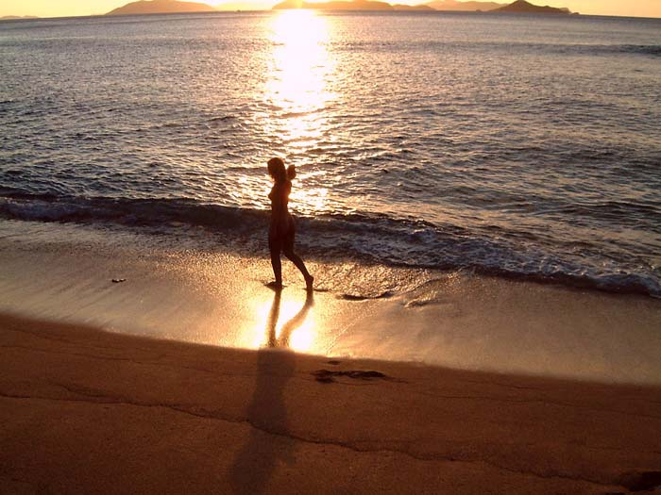
And, sitting on the sand, watching the tides go in and out, she got to thinking about the great curse of her life and how to undo it. The motions of tides, of the earth and the sun, gave her perspective. The way to get out of it, she decided, was by the truth.
. . . .
"Friends, welcome. A year ago I stopped wearing clothes. Since then I have met many wonderful friends like you, and have been through many experiences. I have learned a great deal, and will be always thankful and lucky that I have your love and your respect. Being naked has also allowed me to love more fully and more deeply.
"Life goes on, and I have felt myself entering another phase. Nudity was not really my religion, it was something I was called to. Now I feel myself being called to wear clothes again. I have here in my bag some things I will now put on. This is something that I do not do lightly, the year of being naked was so wonderful and enlightening. I will now continue in life, wearing clothes like everyone else, but remembering and keeping the lessons and the power of love which I experienced and acquired during my time being naked."
The words were spoken by the naked girl to the ocean. She was standing at the edge of the surf on her seventh day at Honeymoon Beach, practicing the words for the twentieth time. The speech she was going to give on her third day back. She had formed a plan. She would announce a prayer gathering for in front of Rossland Hall, and invite all her friends, and then take borrow a pair of Jen's shorts and a T-shirt to put on in front of everyone.
It was a good way to end her ordeal. It had the element of truth -- she could no longer go on living a lie, pretending she was naked because of her religion. And how could the Dean do anything to her? She remembered him calling her to his office at the end of the spring semester, and offering her the chance to put clothes on again. She refused, it obviously being a trick, and at the time she was sure she was leaving the college for good anyway. But so many people on campus liked and respected her. She would invite Professor Congi too, who was the Assistant Dean, and who would surely be supportive. If she put on her clothes in the way she was planning, there was no way the Dean would expel her. The more she thought about it, the more absolutely sure she was of that. And then, of course, afterward she would go to the woods and ceremoniously burn her diary, which was still secreted in the backpack she had left in Terri's apartment.
It was in this manner that Tami Smithers decided to put on clothes again. She realized there was a reason for her incredible bad luck across the country, where she had been unable to find clothes despite her most desperate efforts. God was denying her clothes until she corrected the falsehood at the origin of it all, this lie she had been living. Only then would she be allowed clothes again. By putting them on herself, on purpose, right in front of the administration building, she would correct what had been false and unfinished for a year.
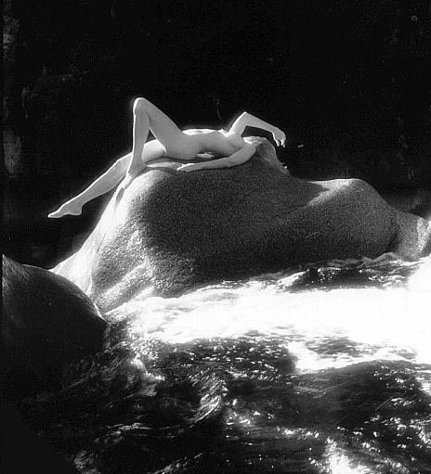
That night, lying on the sand under the stars, Tami had the best dream she had ever had, of being happy and married to Rod and with little kids running around. And a job teaching mathematics at a college. She was clothed. There was no element of nakedness in the dream. It was the dream of a normal person.

The Unintentional Nudist XII: "Tami Smithers Was Here", Part 40 (Conclusion)

This is a real find. A beautiful naked girl sleeping on the beach, lying on her stomach, arms and legs spread as if out on a mattress. Some banana peels next to her. A wonderful body, tight and trim. Maybe not even 20 years old. Deep American-style tan, all over, not a bikini line in sight. She must spend a lot of time out here. . . The tan sets off the white sand sticking to her bum and her calves . . .The best bod I've drawn on this latest trip to the States, possibly ever . . . Ordinarily I'd ask permission, but waking her would ruin the pose . . . Bloody wonderful . . .
"Oh!" Tami awoke with a jolt. She blinked and had the feeling she was being watched, and had the concomitant desire to somehow cover her butt. She got up and turned around and reflexively covered her breasts with her hand.
It was a man in a biker jacket and dark jeans and boots, around 35 or so, sitting cross-legged, sketching on a pad. "Sorry, luv. I'll stop if you want. You are just so beautiful." He had a working-class Brit kind of accent. He showed her the pencil sketch. It was artistic, sparse, and very skillful. He had captured the back of her head, the turned shoulders, the loose hair, her bent arms, and her back, and the beginning of her butt, as she had been lying asleep on the sand. Tami was a little upset at being sketched without her permission, but the drawing was very pretty and flattering. She thought briefly of that portrait unveiled at the Chalfont banquet, the beautiful, intelligent naked girl reading a book. A girl that she often wished she could be.
Tami sat up on crossed legs and used her other hand to cover her pussy. All she could say was, "That's a very good sketch."
"Thanks, luv," he said. "I do these a lot. Want to see?"
He beckoned for her to come closer and she decided he was not dangerous. He had no gun or knife on him and if he lunged after her, she could outrun him or dive into the surf. Still covering her breasts and pussy, she sidled over to him and watched him riffle the pages of the sketchbook.
The drawings were finished and high quality. This fellow was a professional artist of long experience. And his drawings had a constant theme -- women who were losing their clothes, tight skirts or dresses that were getting caught in elevator doors, kite strings, chairs. It was the same woman -- blond, busty, big amazed eyes, looking like that woman Jenny who Tami had met twice. The Jenny who tried to give clothes to Tami but had so much trouble taking them off. Well, in these drawings, Jenny seemed to have the opposite problem! Tami smiled. There was a sense of humor that showed through the drawings, playful and not at all sadistic.
"Do you live around here?" The man's voice broke through her musings.
"Uh, no. I'm away on summer break from college. Actually, I'm not sure even what state this is. I've been wandering around the beaches."
"This is Florida, on the Gulf of Mexico. . .Where are your clothes?"
"I don't have any," she said, holding her hands tighter against herself.
He laughed. "For someone who wanders the beaches with no clothes, you sure are shy. I don't often draw totally naked women, but you have about the prettiest body I ever saw."
Tami smiled and blushed. "Thanks." In spite of her shyness she couldn't help feeling flattered when someone said that.
He extended his hand. "Biker. Or you can call me Nut Case."
Tami could not help but giggle, realizing at the same time how this man must make a living charming women into posing for him. "I prefer Biker. My name is Tami. Are you English?"
"Yes, I'm a Brit, biking around the States for the summer."
"I didn't hear any motorcycle."
"It's a ways back, near the road."
Tami followed him to his bike. It was a ratty and old but it obviously worked. He gunned it and rode in circles, then shut it off. "That was to impress you."
Still holding her hands in front of her, the naked girl laughed. "I'm impressed. Though if you ask me it sounds like your timing's too advanced."
"What?"
"I bet you burn a lot of oil, and after a long run the bike keeps spitting after you try to turn it off."
He smiled. "That's exactly right. You are smart as well as beautiful."
Tami served him up some bananas and pieces of coconut pulp, and then he asked her to pose. After some initial hesitation she dropped her hands and she found herself spending the next few hours climbing a palm tree, standing in the surf, lying on the beach like a model. These were tasteful poses, not blatant exposures like with Professor Brignon.
Tami was glad that someone nice had walked into her travels. She did not ask him for clothes, having decided that the putting on of clothes would be saved for the ceremony she had planned, not that he seemed to have anything extra for her to put on. And he was so comfortable to be around that she almost forgot that she was naked. If nothing else, he cheered her up. She loved this place but missed her loved ones, and was depressed at the almost certain prospect that she would not get back to college in time for the fall semester.
As they sat, eating wild asparagus, Biker showed her the drawings he had made of her poses. "You make women look really beautiful," she said.
He was charmingly modest. "I'm just a bloke who goes drawing."
The drawings were spare but flattering. One odd thing was that in all the poses Biker had her wearing black pumps. In fact, all the women in his drawings had black pumps. "I see you like shoes."
Biker chuckled. "To tell you the truth," he said, "I can't draw feet."
"Well, here's your chance to practice." She planted her bare foot onto the sand in front of him. He gamely concentrated. One, two, three quick sketches. The first one was pretty bad but by stages they got better.
"Do you have any tools?" Tami said. "I'll fix your timing for you."
As the naked girl kneeled in front of the bike, fiddling with the little distributor, Biker sat behind and drew the pose. When she was finished she flung a leg over the seat and pushed the throttle down with a hard bare foot. The engine roared, sounding much better. She smiled at him, crossing her arms with pride. He drew that pose too.
At his request she got up and did another pose, of her stretching her clasped hands over her head, back arched, as if just waking up. Somehow the fact that her pussy was almost in his face did not embarrass her. It was almost sunset and the long shadows of palm trees played across her concave tummy.
Finally he put his sketch pad away and walked over to his bike. "Here's my card, luv," he said, "that is, if you have a place to keep it. I'm sorry but I've got to get going. I'm heading to the big bike gathering."
"Where is that?"
"The big Labor Day to-do in Laconia."
The naked girl's face changed with a degree of astonishment that the artist had never seen approached.
"LACONIA??"
"Yes, it's an annual -- "
"LACONIA, NEW HAMPSHIRE??" Her eyes were exploding like sunballs, over a wide open-mouthed smile.
"Why, yes."
"TWENTY-FIVE MILES FROM CAMPBELL - FRANK COLLEGE??" Her eyes were as wild as her hair.
"Um, I'm not sure. Want to come with me?"
"YES!!" The naked girl pumped her fist, making her breasts dance and jiggle. "YES!! YES!! YES!! WOOOO!! WOOOO!!" She kicked up her legs and arms, pushing sand up with her toes, then did a somersault and stood up again, arms spread, shaking her shoulders so as to jiggle her breasts. "WOOOO!!"
The artist wondered about this crazy naked girl and briefly regretted having offered her a ride. He was about to say something when she did cartwheels away from him and ran off in between two stands of palm trees. "WHEEEE!! OONGA BOONGA OONGA BOONGA OONGA BOONGA!!" She disappeared and her voice died away, fading into the surf.
A moment later her voice returned, followed by her own naked self, kick-dancing like a Cossack with her arms folded under like a chicken as she passed by him on her second go-round. "YA YA YA YA YA YA YA YA YA YA --" Once again she disappeared into the trees and her voice faded away.
As she appeared again, she strode and waved like someone completing a showy home-run trot. Then she changed to skipping like jumping rope, arms extended to the side, the tanned, tight breasts wildly bouncing up and down. A double-flip, gymnastics style, landed her on her feet right in front of him, a little winded, shoulders back and arms down behind her. Before her breasts had stopped bobbing she said, "YES!! . . . When do we start??"
He smiled and got up onto the bike. "Hop on."
She held up a finger. "One more thing! Wait." He followed her to the beach. She frantically pressed the rocks into the sand. They said, "Tami Smithers Was Here".
She put her bare feet onto the stirrups, just behind his boots, and put her bare arms around his waist. It was almost dark now. He gunned the bike and off they went.
. . . .
They traveled by night, rested by day, during which she hid in bushes while he brought her food. It took two nights, two nights of feeling the air rush over her hair and her feet and her shoulders. They avoided the interstates and the big cities, they went on old country roads and the few who saw the naked girl on the bike roaring past them in the middle of the night figured they were seeing things, or maybe she actually had on flesh-colored tights, not an unusual gimmick for a biker chick.
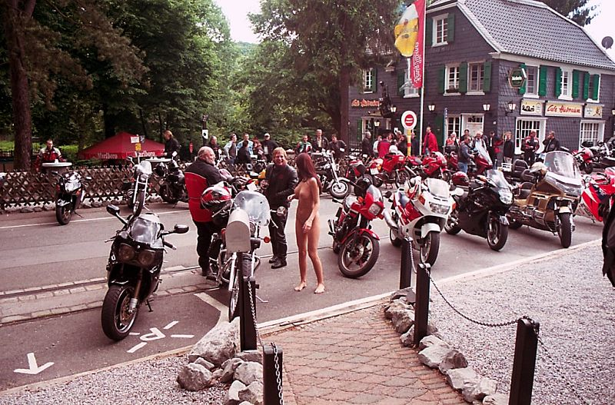
About the biker convention, not much needs to be said. She was the undisputed queen for the day she was there, and though no one could touch, they all looked! With Biker as her friendly bodyguard following close behind, she paraded and waved through the woodsy grounds like the winner of a pageant, inspiring many more drawings of his to come.
And now, along the traffic circle in front of Rossland Hall, the parked cars of parents unloading their kids for the fall semester, the amazing sight of a naked girl on the back of a motorcycle. She gave Biker a big good-bye hug and ran onto the campus in front of the astonished onlookers.
Yes! There was evil old Rossland Hall. The naked girl ran across to the art building. Yes! There it was, where the whole business started.
A line of girls marched in single file behind Samantha, one of the freshman who hadn't gotten caught on that fateful night, now an Alpha Omicron sister. Samantha's solemn ceremony was disrupted by a wild-haired, tanned naked girl who ran past and yelled at the initiates, shaking her head and laughing: "Don't do it!! Don't do it!! Run away!!"
Fellowes Hall! And there was the little alcove next to Rossland where she used to study! The gym building! The Gloria Humboldt Gallery! She was blushing like mad, knowing that flabbergasted freshmen were staring at her from all over the crowded campus, yet she was so happy!
She briefly caught her breath and then sprinted to Pilgrim Hall, her feet slapping up the stairs, running past people who recognized her and others who could not believe what they were seeing.
She stood in the open doorway of Room 207. A moment of silence, then she heard the shout of surprise and joy.
"TAMIIIII!! Yay Tami!!" It was Jen, and Mandy, and Muffy, and Dawn, and Mayree, and Brad, and Marisol -- or at least that's all she could make out, through the bleariness of her eyes now wet with happy tears.
"Hey, guys," she said.
[end]

