Olena and Alina - Making Hay
Olena-Alina
Olena asked her best friend Alina, "It's too beautiful a day to spend inside studying. Let's play a game."
Alina said, "But your games always end up with getting me naked."
Olena smiled. She reached out for her friend to take her hands. "Come on now. Even if you do end up naked, so do I, and you love it."
Alina sighed. She knew her friend was right, but still, "Can we at least play somewhere where we'd be by ourselves?"
Olena pulled her friend standing. "Of course! We'll take a walk out to the fields. No one will be there."
The two girls walked hand-in-hand across campus and down the back roads to the farmlands. Alina constantly looked back over her shoulder as if someone might be following them. No one even noticed.
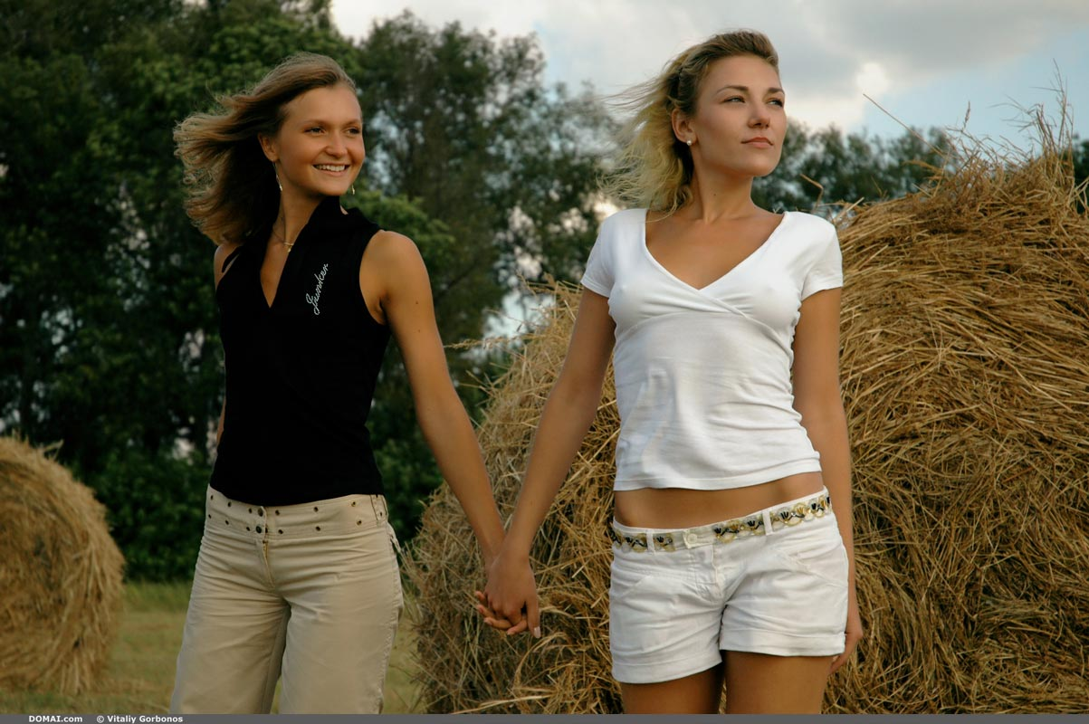
Alina said, "I don't think so. You'll walk us straight back to campus!"
Olena asked, "How long did we walk to get here?"
Alina said, "I don't know. Maybe twenty minutes."
Olena pointed out that even if she did spend her two minute leader time walking them both back to campus, after two minutes Alina could negate the entire turn by walking straight back away from campus. Plus, they both would be naked, so Alina had little to worry about Olena parading back naked, too.
Alina had to think about for a little bit. She asked, "So what's your tricky plan this time?"
Olena admitted, "Just getting you more comfortable being naked outdoors is all I want. I love seeing the sun light on your gorgeous skin."
Alina said, "Thanks. I do love seeing the sun on you, too, but I don't think I'll ever get comfortable being naked outdoors."
Olena pulled off her own blouse, "Hurry up then. It's not the naked part that has you nervous. It's the getting naked part, right?"
Alina smiled seeing her friend topless, "Of course, you're right." They both stripped down completely nude. Alina asked, "What if someone sneaks up and steals our clothes while we are playing your game?"
Olena took a moment to look at Alina's gorgeous naked body before saying, "No worries. No body will be sneaking up. We'll see them a mile away. But we can hide our clothes under this hay roll. No one will think to look under it."
Alina looked at the massive hay roll, but together they managed to roll it on top of their clothes. Safe and secured. The girls took each other by the hand while eying each other.
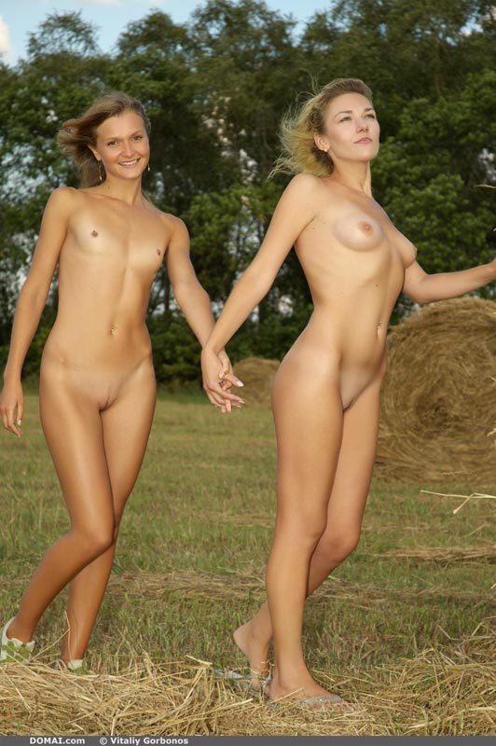
Olena said, "I do love the sunlight on your skin. Now, you lead. And while you lead, I cannot let you go. I must go wherever you want me to go. Just for two minutes, then you follow me. Got it?"
Alina nodded and pondered her next move while stealing glances back at her naked friend. She decided it was safest to walk further from the road and deeper in the field. Olena happily followed along holding her friend's hand as she led downhill.
Two minutes later, Olena said, "Okay my turn!"
Alina looked around and decided that even two minutes wouldn't get them back anywhere near the road since it would be uphill walking. To her surprise, Olena didn't walk back towards the starting point, she walked further away. Another two minutes further away. Alina was nervous, but also relieved her friend wasn't trying to trick her into walking across campus naked... again.
When it was Alina's turn, she turned to remain in the field rather than enter a wooded area. The girls kept walking hand-in-hand. Every couple of minutes the girls would acknowledge that the other was leading, but in reality, they both were just wandering aimlessly together. Giggling, laughing, and admiring each other for being brave enough to remain nude for so long. Together it didn't seem to matter. They enjoyed their time.
Olena would stroke Alina's bare skin complimenting her on her beauty, and she'd receive a light kiss, pet, and a return of the compliment as her thank-you. They giggled whenever the other caught them staring a little too long at them. It was all fun for both.
When they finally did reach the end of the field nearing a road, it was Olena who suggested they not go further. Alina was smiling. For some reason she did! "Olena, it's my turn to lead, and I think we should cross the road."
Olena looked long in both directions before the two girls ran across the road.
Soon enough, the new field came to an end along a fence line. From there they could see the country side. The farm house wasn't far, and if they could see the door plainly, Alina knew anyone in the house could see them. She decided it was time to return.

This time before crossing the road they hid behind a tractor. A pickup truck pulling a trailer whizzed down the road. The girls giggled. The driver never noticed them, but they did wait for a minute until he was out of sight before running across the road. Both girls seemed to know that moving away from the road was smart. They stuck near the woods as they walked back up the rolling hillsides.
As they approached one open field, Alina asked, "Is this the field we left our clothes in?"
Olena's eyes widened, "I think so."
Alina's mouth dropped open, "You think?!?! You don't know?"
Olena said, "All the fields are looking the same to me right now. I do know we hid our clothes under a hay roll near the road."
Alina asked, "Was it the second row or the third?" Olena could only shrug.
They spent the next two hours pushing hay rolls and getting exhausted. With maybe a hundred more hay rolls in this field alone, Alina was the first to speak the naked truth, "We'll never find the clothes. We don't even know if we are in the right field. I'm tired. Let's just go home before we are too tired to even walk."
Olena looked into her friend's eyes, "I'm so sorry. I didn't plan this. I just wanted you to get more comfortable being nude outside. I didn't imagine losing our clothes."
Alina hugged her friend, "I know. It was really my fault. I was the one who thought someone might steal our clothes." Olena hugged her friend tight.
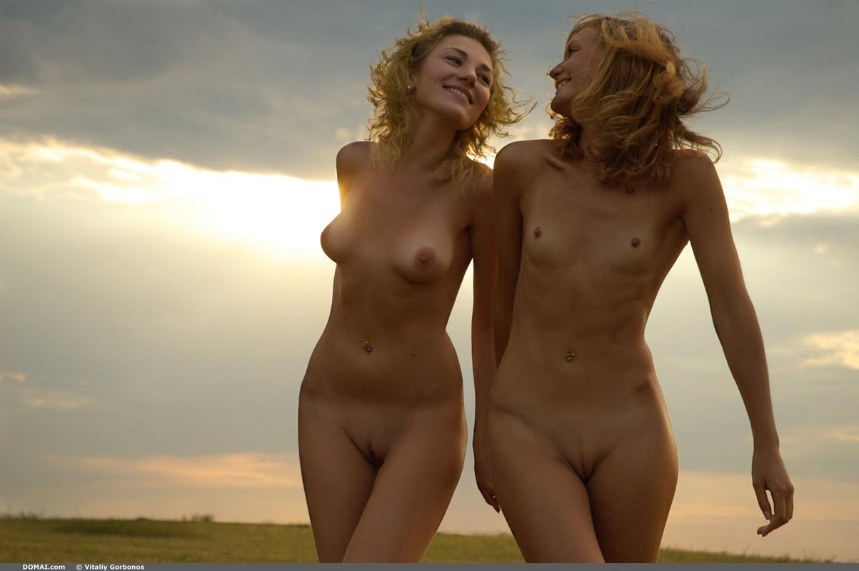
As they walked, they talked. Olena was preparing her naked friend for the inevitable. They were about to walk across campus naked, once again. Soon someone would see them. Alina was told to just keep ahold of Olena's hand and keep moving as if nothing was wrong. Anything else would only delay them longer. Alina squeezed her best friend's hand as they started to pass the outlining houses near campus. A few cars passed them; one honked. A man tending to his lawn stopped to admire the beautiful view of the young women walking by.
Fortunately, the residents have seen plenty nudity around campus to not make a big scene. Some enjoyed the show, like the man. Others attempted to ignore them, like a woman calling her husband inside for dinner.
Both girls sighed as they crossed the street back onto campus. The rules changed from here to their dorm. Since they are nude, the code allows others to fondled their exposed bits. They had to watch out to not become sexually excited, too. That was deemed consent and willingness. But these two girls knew a good trick to keep most at bay. If they were approached by anyone, they stopped to kiss and fondle each other. Their plan usually worked. Two beautiful, naked females kissing and touching each other was not something to break apart, not by guy or gal, alike.
Alina had to whisper to Olena to stop for fear she might have an orgasm in front of the crowds they attracted. Olena reluctantly allowed her own frustration to build to not delay getting back to the dorm.
Once inside the dorm, the girls raced up the stairs towards their room, but Alina pulled Olena pass their door, "First, we wash off the dust and hay bits. Then we can finish what you started."
Olena laughed as Alina giggled.

