Melissa the Naked Garage Girl
Melissa was excited. She was eighteen and had just left school. Her favourite subject in school was boys. Now she had left she hadn’t changed, that’s why she had applied for a job in a local garage, Pete’s Wheels. She thought that in a garage there would be mainly men and boys working so she might make lots of friends.
Melissa was over the moon when she had a letter saying that Pete would give her a trial for one day in the garage. As she entered she saw two handsome young men looking under the bonnet of a car.
“Excuse me, gentlemen, can you tell me where I’ll find Pete?”
One of them pointed to a short flight of concrete steps. “Go up the steps. His office is at the top.”
Pete, a jolly middle-aged man with a ready smile, greeted her warmly in his office. “Have a seat Melissa,” he said.
He looked her up and down as he told her about the work she would be required to do both in his ofice and around the garage. “Of course,” he said, “this will be your probation day where you’ll try out all sorts of jobs with the lads. Then, at the end of the day they’ll all vote on whether we should offer you a permanent job.
“Sound all right to me,” enthused Melissa who liked the idea of working with men and boys all day.”
“Just one other thing,” said Pete. “All our workers on their probationary day have to work naked.”
Melissa just looked at him stunned. “Work nak. . . You mean I’ll have to work all day without any clothes?”
Pete smiled at her. “That’s right. It’s just our custom with all our new apprentices. “Of course if you don’t think you can . . .”
“Oh yes,” broke in Melissa. “I’m sure I can mange to . . . er . . .work in the nude - just for a day. If all the others managed it I suppose I can too.”
“All the lads will be expecting it, so they won’t mind,” added Pete. “If you just strip off you can put your clothes on your chair, then I’ll take you down and introduce you to the lads.”
Melissa took a deep breath, then took off her clothes, folded them and placed them on her chair. Peter sauntered around his desk and picked them up. Then he walked over to the wall, opened his safe and locked her clothes inside. “They’ll be quite safe in there until it’s time for you to go home,” he said casually. OK let’s go and meet the staff.”
Melissa felt totally vulnerable and humiliated as she followd Pete down the concrete steps which felt very cold under her bare feet. A young man in the shop area was busy loading bottles of drink onto a trolly. He looked the naked Melissa up and down and smiled broadly.”
“This is Brad, Melissa” said Pete, introducing her. He orders supplies for the shop. You can give him a hand for a while. Perhaps you’ll hand her around to do some of the other jobs afterwards Brad.”
Brad walked over and shook Melissa’s hand. “Good to have you with us,” said Brad. “Quite a change to have a girl working here - especially one who looks so good naked. I’m sure the boys will be impressed, especially with your closely trimmed pussy.” He looked down between her legs as she blushed bright red with humiliation.
Pete returned to his office and left Melissa in the care of Brad. He showed her how to stack the shelves and helped her to climb the steps to fill the top shelves. He placed a hand on either side of her hips as she stood uncertainly on the top step. Someimes he seemed to place the steps rather short of the shelves so that Melissa had to bend over to reach them. But he was very kind and held both her legs assuring her that he would not let her fall.
Some of the customers who came into the shop showed great surprise at seeing a nude girl working there. There were a lot of whispered remarks and laughter from them. Some of the female customers seemed equally as embarrassed as Melissa.
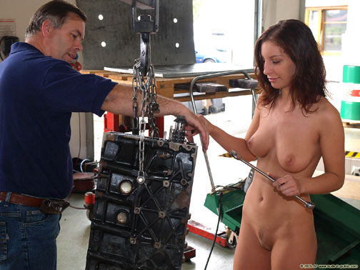
Brad then took her into the engine shop and introduced her to another man called Tim who showed her how to hoist an engine into place and all the various spanners and other tools used to take it apart. He was very helpful and, when Melissa found the spanners too hard to turn he would stand behind her and place his hand on hers to help her to turn the spanner.
Sometimes Melissa would press against the engine and get oil on her breasts and tummy, but Tim was very helpful and used a clean cloth to clean it off for her.
He was also very helpful in showing Melissa the best positions to get in to work on the engine such as crouching down to get at the bottom parts. He generally criuched down in front of her to see that she was doing the job properly.
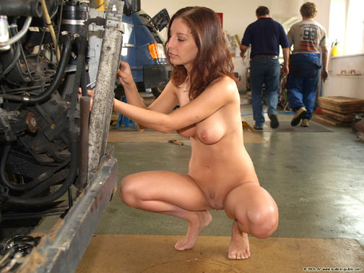
Tim then took her into the next room and introduced her to Mick who worked on the heavy vans. He had a young lad, Colin, who was also an apprentice. They chatted to Melissa for a few minutes as they looked her up and down making her feel totally embarrassed.
Then they explained that it was necessary to get underneath the van from time to time to inspect the exhaust system. They told her how to lie down on her back on the trolly.
“Spread your feet as wide as you can,” said Colin. “It will make certain that you don’t fall off the trolly into the oily mess under the van. They crouched by the side of the van and watched as Melissa slid underneath helping to push the trolly with their hands. Melissa realised that their hands were right between her thighs as they did this and she started to get sexually aroused by it. She also realised that both the guys must be staring right between her legs and her exposed pussy lips.
Melissa sometimes emerged with the front of her covered with bits of rust off the van’s exhaust system, but Mick and Colin were very kind and helpful at picking the bits off her and helping her to clean up in general.
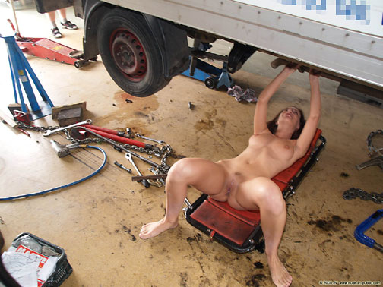
She was next taken into the tyre shop where there were five young men who eagerly gathered around to meet her and explain the work they did. They seemed a very sexy bunch which did nothing to relieve the sexual arousal that Melissa was now feeling. Their remarks didn’t help either: “Like your shaved twat babe”, “Oooooh your skin feels so smooth”, and “Lovely rounded butt” increased that stirring sensation between her legs.
Eventually it was time for lunch break. Colin, the apprentice, made a list of what everyone wanted to eat and then said he would go to the local takeaway to get it. Some of the tyre shop lads did their best to humiliate Melissa still more by suggesting that she should go with Colin to help him.
“What! Like this? she blurted out. It’s bad enough having to be seen naked by all you guys without walking down the road like it.
When Colin returned they all sat around in a circle to eat their lunches. Melissa, the only female, and totally naked, felt even more embarrassed as she felt all those male eyes roaming all over her exposed body.
“C. . . could I put my clothes on just to eat my lunch, please?” she asked timidly.”
“Don’t see why not,” said Brad. “Where are they darling?”
“Pete put them in the safe,” she replied.
“Oh dear,” said Brad, “Pete’s the only one with the key to the safe and he goes home to lunch. Never mind, if you feel cold I’m sure a few of the lads will help to warm you up.” There were huge guffaws and laughter all around at this comment which made Melissa feel even more humiliated.
When she’d finished her lunch she thought she might be able to escape all those eyes by going for a smoke. “Er . . . is it all right to smoke in here?” she enquired.
“We can’t actually smoke inside the building,” replied Colin. “Pete says it’s too dangerous. But you can go out to the doorway and have a smoke there.” So poor Melissa was forced to stand almost on the pavement to smoke her cigarette. Several people walked past as she did so and gave her some peculiar looks which made her feel even more embarrassed.
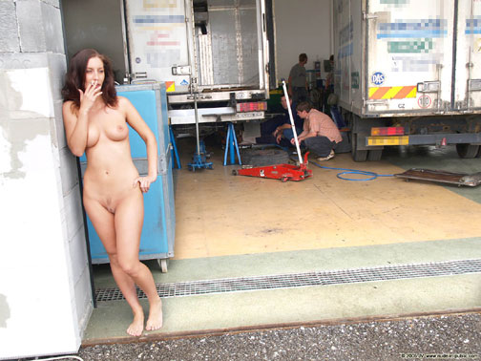
The afternoon passed off fairly well as by then Melissa was used to working and talking to the men as she stood before them naked. And by then they were all taking it for granted.
At the end of the afternoon Pete emerged at the top of the steps and called everyone into his office. The small office was rather crowded and Melissa was hemmed in by men on every side.
“Right, gentlemen,” said Pete. “You’ve been working all day with our new apprentice, Melissa. Now I want you to vote on whether you think she should be given a permanent job. But before that I have something I want to say to all the men. Melissa, will you wait outside the door please. This is just man talk.”
She had to squeeze past all the men on her way to the door and felt a lot of hands helping her on her way. When she was outside Pete smiled at his staff and addressed them in a low whisper. “I told Melissa that it was our custom for all new employees to work naked for their first day. She really fell for it, so I don’t want anyone telling her anything different. OK?” The staff all signalled their agreement.
Melissa was then allowed back in and stood at the back of the men by the door. “Right,: said Pete. Now I want you to vote on whether we should employ Melissa here permanently. All in favour raise your hand.” Every hand went up. Melissa was both pleased and relieved as she looked at all the raised hands. But she knew, personally, where some of those hands had been during that day.
“The job’s yours Melissa,” announced Pete, but before I let you have your clothes back I'd like to take a photograph of all the staff. Melissa, I want you in the front row standing between Mick and Colin.” She meekly obeyed standing awkwardly with both hands covering her pussy. Pete looked at his workers and rubbed his chin. “Mmmm . . . those in the back row had better stand on chairs so I can see you better . . . yes, that’s it.” He hesitated again. “Er . . . just close in a bit. I don't want anyone missing on the ends of the lines. Try to look really chummy.” Everyone laughed at this. “Oh, and Mick and Colin, just hold hands with Melissa.” They grabbed both her hands as she turned bright red realising that she couldn't cover anything now. She was naked and completely exposed to Pete’s camera. She suspected that was what he wanted.He took a series of photographs. Afterwards he looked at Melissa.“Now, I expect you’d like to have your clothes back.”
“Yes please,” she replied.
There was a hearty cheer from all the men and boys as many willing hands lifted her above their heads in Pete’s direction. When she was passed over the heads of the boys from the tyre shop she felt quite a few strong fingers working their way inside her very juicy pussy. One of them made a very loud remark: “And who’s got a juicy pussy then?” This was accompanied by other comments such as “Naughty girl” and “What have you been doing all day?” There were great roars of laughter all round at these hilarious comments.
Poor Melissa couldn’t get her clothes back quickly enough. There were many willing hands helping her to get back into them, doing up her bra and sliding her knickers up her legs.
“Thanks everyone,” said Pete. I'll let you all have a copy of the best photograph. Melissa groaned inwardly at his words, wondering how many people that she knew might see it. Everyone then dispersed and she found herself going out through the door with Colin. “Enjoy yourself?” he asked her.
“Well,” she replied, “it was a bit embarrassing and humiliating but I eventually got used to it. You are an apprentice too aren’t you Colin?”
“That’s right. I’m the latest recruit - until you came along today.”
“So I suppose you had to spend your first day working naked as well,” said Melissa.
“Me?” asked Colin in surprise. “Oh. . . er . . . yes, of course, I’d almost forgotten that.”
Melissa stopped in her tracks. “What! I don’t think I’ll forget it in a hurry.”
“Well, we all enjoyed it,” said Colin. “See you tomorrow babe. And if you want to work naked again, I don’t think any of the lads will mind.”

