Karen Joins the Girl Scouts
by sevispac
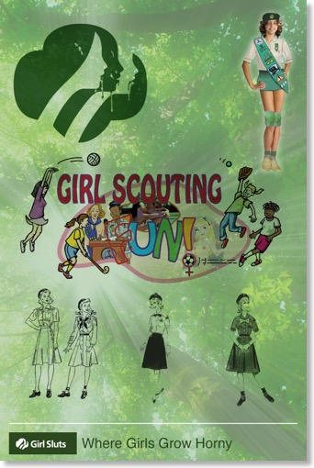
"Alright, girls, that's it for the community service report. Don’t forget that the official Girl Scout organization names have changed. Remember, we’re no longer Troop 125, instead we’re called the 125th Passel. Also please remember to call me by my new official title, ‘Mistress Ella’ rather than Miss Roberts.
Now it's time for the part of the meeting everybody has been looking forward to. This month we're going to put on a fashion show to introduce the new uniforms the Girl Scouts have brought out in support of the program friendly nudity themes which are making such a stir in school today. Needless to say, this is a huge change in Girl Scouting, and completely reverses most of our old policies. Be sure to look for the new logo on our web site, or anything you buy so you know it's up-to-date. The new logo is on the patches which I've passed around, and consists of a pink female symbol with our old logo of three girl's faces in the center. The pink circle has three blue male arrows sticking into it, symbolizing the three ways in which you can be sexually penetrated.

"In case any of you don't watch the news, go to school, or ever leave your house, I should tell you that the Girl's Enhancement Program has been going on for almost a year now, and tonight we're lucky to have with us the famous Karen Wagner, who was among the first to spend a week naked at Central High School. Karen will be helping to model our senior Tart ensemble, but before we get to that we will be starting with our Nymphette wear. Please give Cindy a big hand as she starts us off with the 'Little Hottie' look.
"Here she is modeling the new Kelly green vest. As you can see, it has three brass buttons and is very modest when completely done up. Since Cindy is only twelve, she has been able to fasten all three buttons.
"The secret of the vest is that it comes in only one size. As our girls mature it fills out and becomes very interesting to boys when you leave the top button undone. Very soon it has to be worn with only the bottom button done up, which provides a very attractive push-up effect like the one Andrea is showing us here.

"Here's Karen wearing the basic uniform, a return to our traditional look with a kelly-green skirt, white knee socks, and black patent-leather shoes. The skirt is much shorter, but otherwise you might mistake her for a 1950's girl scout. Even the white blouse looks the same. Only when the worn without the vest do we notice that the body of the blouse is totally see-thru. Since the wearing of a bra is prohibited by the new uniform policy, the effect varies from innocent to daring, to nearly topless depending on how many of the buttons you decide to leave open."
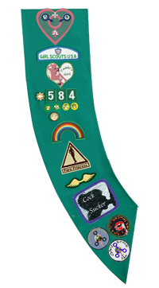
Penny is modeling our traditional Merit-badge sash, which is still worn over the Right shoulder and left waist, leaving the left breast bare underneath the blouse. "That doesn't mean that accessories can't be worn, however. Penny, would you please come back out?"
Penny emerged from behind the curtain and once again strolled down the runway. This time she was dressed like Karen, her sash arranged charmingly over her right breast. You could hear a gasp from the girls as they caught sight of a golden chain falling gracefully over the sash, one end clipped to each of Penny's nipples through holes in blouse and sash.
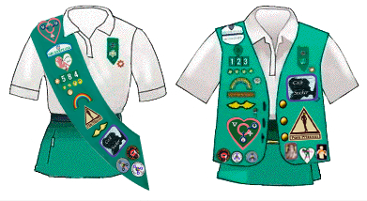
"The official Girl Scout nipple ring has our traditional green and gold symbol. Our fourteen-year-olds are encouraged to have their left nipple pierced, and are authorized to get their right nipple done as well, once they receive their merit-badge sash. The titty chain is optional.
"That brings me to the subject of our new merit-badges. The GSA council has announced nine new categories. You can find eligibility in chapter six of the new Girl Scout Handbook, or they can be downloaded from the headquarters web site.
Mistress Ella smiled. "Every Girl Scout will automatically receive the VOA patch. It will be awarded at the Rainbow Bridge ceremony for new girls. It represents your three virginities: Vaginal, Oral, and Anal. As you grow up and lose each of your virginities the Girl Scouts will help you celebrate by awarding you a blue male pin to place on top of the appropriate letter.” Some of the younger girls were shyly looking down at the floor.
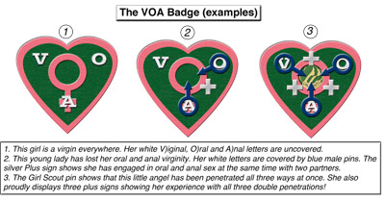
"The Girl Scouts believe that your early sex experience is very special and should be as public as possible. We will be adding a ceremony at the end of every quarterly passel meeting. Any girl who wants to volunteer will be allowed to give up any of her three virginities in front of our assembled families. At the end of the ceremony, these girls will receive special gold pins for their VOA badge, along with permanent membership on our new Passel Porn Site.
"There’s still more to the VOA patch. Even after you lose your virginity, you can still earn more pins to wear on it. Girls can add a silver Plus pin between any two letters if they are penetrated both ways at the same time, and any girl who does all three at once can wear her GSA pin in the middle, so it looks just like our new logo!
"The other new categories are:
”Exhibitionism. Points can be awarded just for wearing the new uniforms, but they vary according to where you are seen. You can also get credit for successful completion of the Program at school. You must have this badge before you can start to work on Porn Princess." Mistress Ella held up a picture of the merit badge. It showed a girl about Penny's age pulling up her shirt and showing her little tits.
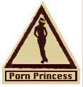
"Porn Princess. This one is earned by having your picture taken and published in Girl's Life or on the web. There will soon be any number of porn sites accredited by the Girl Scouts, but in the spirit of community service you aren't allowed to take money for work on this merit badge. Any fee you receive must be donated to charity or turned over to the Passel. You must also make sure the official Girl Scout icon appears on the each of your photos. You can find a list of points awarded for simple nudity on up to various sex acts in your handbook or at the Girl Scout web site. One point for topless shots, 10 for facial cum-shots, 150 points to earn the merit badge. This merit badge had the silhouette of a nude girl in a gold tiara.
"By your age most of you girls know what fun it is to play with your pussy. How many of you have done it?
"Wonderful. Any of you who haven't discovered how much fun it is can find instructions in the 'Mistribation' chapter of the Girl Scout Handbook, or on the GSUSA web site. We're also giving a new merit badge for this valuable skill. To qualify you must have two adult witnesses who can certify that you brought yourself to orgasm at least four times in their presence. Exception! We're going to be having 'fun time' at all our weekly meetings, and if your scout leader sees you jill off with your friends, she can certify your badge on the spot!
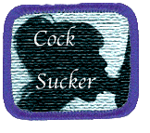
"The Cock Sucker badge is an intermediate step in between simply showing yourself off without actual touching, and the more advanced practices we all look forward to seeing you try. Many of you aren't yet ready for intercourse, but are curious about boys. This badge gives you the perfect opportunity to satisfy your curiosity. It's easy to get. All you need do is have at least two boys certify that they have put their cocks in your mouth for at least four minutes each. Pictures aren't required, but they're certainly encouraged.
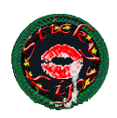
"Sticky lips." This one had a picture of red lips with a dollop of white sliding off one corner. "Oral sex to completion. Your partner must sign off as fully satisfied, and you must either swallow or take his cum on your face. The choice is strictly his.
"Girls", Mistress Ella winked, "This is the one you want. When word gets around you have this one - and it will - your popularity in school will skyrocket. Make sure you visit the web site, though, and click the cleanup button to read the tips on getting cum stains off your uniform.
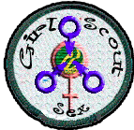
"Sexual Intercourse. Our proper young ladies are expected to call to this the SI badge, not the 'fuck badge' as it is being reported in the press." Mistress Ella showed them a badge with a Girl Scout looking back over her right shoulder at her partner who was penetrating her from behind.
"Group Sex. To qualify for this you are required to participate in full vaginal, oral, or anal intercourse with at least two males at once. More girls and boys are allowed to join in if you want." This one was nearly the same as the new Girl Scout Sex logo.
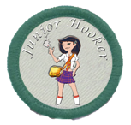
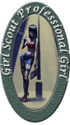
"The next badge is actually a pair of badges. You receive the Junior Hooker Badge the first time you sell your pussy. The Professional Girl Badge is awarded to those girls who sign a contract to let the Girl Scouts solicit them. There are programs for street walkers and call girls, but unfortunately we don't have a Girl Scout certified teen bordello near by. Our passel would like to sponsor one, so let your Scout Mistress know if you're interested, but don't forget your parents have to sign an Age of Consent Waiver. Girl Scout contracts take only 25%, which is much less than a pimp, and you'll be able to schedule 'dates' on our web site. Before you know it you'll be in business, having more fun and making more money than you ever dreamed!
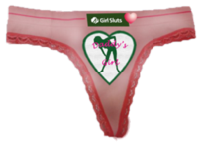
"Daddy's Girl. This is our most special badge, for a very special relationship. Every girl dreams about this, but most never get it. It's given to girls whose daddies certify that they have a very loving daughter. Something else special: This is a mystery badge. It can be given in secret instead of at the regular awards ceremony, and along with the badge for your sash, the Girl Scouts also award a special 'Panty Badge', so you can keep it secret from anyone who might object. If your mother is understanding though, we would love to see you wear it on your sash, too!" This time there was both a patch and a pair of panties for the girls to pass around.
"You might end up wearing both. The panties are thong cut, so they leave your cute little bottom uncovered. If you pull up on the front, they disappear between your lips, leaving the badge to cover your mound. And if you're very careful the point of the badge will rub your clitty every time you move. Some of you are going to be even more squirmy than you already are!"
Mistress Ella giggled. "To make sure you aren't too shy to participate fully, merit badges earned privately will not be awarded until evidence is submitted to the Awards Council. Evidence must consist of at least five photographs for each badge. The photos must clearly show your participation in the activity, and must include unmistakable pictures of penetration and full consummation, including sperm on your face, pussy, or in your mouth as appropriate. All photos become property of the Girl Scouts, and will be posted on the passel web site. Those photos judged sexiest will be submitted to the national council of the Girl Scouts as candidates for posting on the Official Girl Scout Sex web site. If you are selected for this special honor, a professional photographer will be sent out from national headquarters to take supplemental shots of you in the appropriate category. You will be allowed to select your own partners, but if none are available the Girl Scouts will provide at least four for you to choose from, including at least one other girl. By applying for the merit badge you automatically agree to these conditions. The Daddy's Girl Mystery Badge is an exception, but if you come from a loving family we certainly want to have pictures of you playing with your Daddy on our web site!
"Now I have one final announcement." Mistress Ella smiled and winked, and all the girls sat up. "The Girl Scouts are de-emphasizing sports and all the other programs that detract from a teenage girl's natural preoccupation with boys. We'll be starting lots more activities about clothes, makeup, and flirting. Best of all, instead of our spring camping trip, next month our passel will be sponsoring our first annual Boy and Girl Scout Jamboree and Orgy. All girls who complete the orgy satisfactorily will automatically receive the new merit badges you earn there. The Group Sex badge will only be awarded to girls who both suck at least one partner to completion while being penetrated vaginally at the same time by at least one other boy, and are clearly photographed doing so. Needless to say, this is a great chance to fill up your VOA badge!
"This event will be held on the 21st at the downtown Hilton. There will be a live band and a dance floor, rooms for couples, and a romper-room for groups. An all-night buffet will be provided. The events will start at 7 p.m. on Saturday and run until 9 the next morning. There is no charge to participate, because all activities will appear live on pay-per-view, and the council has already signed a contract which will not only cover the costs, but double our budget for next year."
The girls applauded enthusiastically. "Now", said Mistress Ella, participation is strictly limited to Boy and Girl Scouts in good standing, so if there's a 'special someone' you would really like to meet there, make sure to let him know to sign up right away. We're expecting to have the biggest recruiting surge in Scouting history, so pick up as many applications as you need before you leave tonight. Take a few extra just in case.

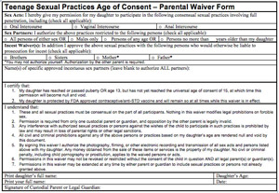
"You will also need a signed Age of Consent Waiver from your parents if you're under 15, plus proof of birth control. You can get a certificate from your school nurse when she gives you 'the shot'. The new uniform dress code will be in effect, but needless to say you aren't expected to keep your uniform on for long. Full nudity from the start is also acceptable.
"Even though you've seen other girls going topless or nude in public, and you high school girls have seen or participated in the Naked in School program, I know that many of you younger girls are not experienced at sex yet, and might be shy about participating. Some of you are still virgins. Please remember that all Girl Scout sex programs are designed to help you grow sexually and discover new things about yourself in a safe and fun environment. And believe me girls, the sooner you try it, the more fun you'll have!
"If you're too shy to join in the orgy, we still want you to come and watch! Be part of the live audience in the romper-room and cheer for your friends! Also, all couple's rooms will be telecast on monitors in the hotel lobby if you want to watch somebody special. Tickets are $25 to the public, but our girls and their families get in free, even if you're not participating. Wear your new uniform, and we'll let you join in if you change your mind and don't want to miss the fun.
"Vivid Video will be handling the filming for Showtime, but there will also be lots of professional and amateur photographers there. Playboy, Hustler, and any number of freelance web sites will be looking for fresh young models, and the Girl Scouts will have representatives there to review any contracts before you sign them. We'll make sure you know exactly what you're getting into, what you have to take off, and what acts you're agreeing to perform, how often, and with how many. Remember, everything is strictly voluntary until you sign a contract. It's fun, and we think it's also great preparation for mandatory programs like Naked in School! And don't forget to pick up a copy of the Girl Scout Guide to Careers in Porn before you leave!
"That's it for tonight's meeting girls. Everybody gather around for the closing ceremony". Chairs were pushed aside as the girls formed a circle around Mistress Ella. "The ceremony has changed, so everybody pay attention. Raise your left hand in the Scout sign, and place your right hand on your pussy. Now repeat after me:
I promise, to try my best,
to serve my country and all the men and boys I meet.
I will be a girl in every way,
and I will always remember that my body is made for pleasure,
both my own and as many partners as I can enjoy.
This I solemnly promise on my Pussy.

