Girl has to submit to pussy shave
posted by Max, 06.03.2006, 00:21
From recent posts I know these will not please everyone, but, speaking for myself I really do like a smooth pussy. It's so easy on the tongue.
Bill dropped in at Hilda's house one evening just as she was emerging from the shower. She was just throwing a pink robe on. Bill took her in his arms and kissed her then he opened her robe and looked down at her pussy. "You haven't been shaving it!" he scolded.
"B...b...but..."
"No buts. You know I like your pussy smooth. I'm going to give it a good licking so open that robe and sit on the settee." Hilda meekly obeyed with a frown. Bill disappeared into the bathroom and emerged with a razor and a can of foam. He spread the foam liberally over Hilda's semi-hairy pussy.
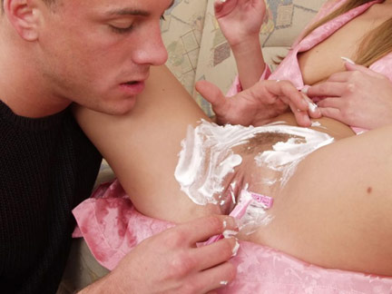
His skilled hands swiftly started to shave Hilda's vagina as she squirmed a bit. But Bill only laughed at her. "This'll teach you to do it yourself." he said.
"D'you mind if I smoke to calm my nerves?" said Hilda. "You are getting a bit near my clit with that razor."
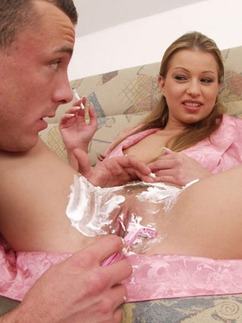
Bill soon had both lips as smooth as a baby's bottom. He noticed that Hilda's vagina was turning pink and opening, so to get her aroused even more he pushed a finger inside her.

He opened her pussy wide to look inside. Yes she was getting nice and juicy. A slight sigh escaped Hilda's mouth.

When he'd finished Bill took the towel and wiped the remainder of the foam away. "Now that's what I call a nice shaved pussy. Just how a pussy should look."
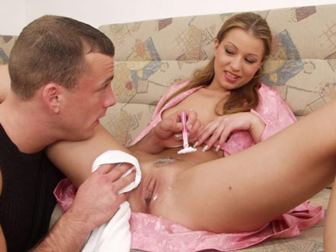
Bill bent forward and tried out his handiwork with his strong tongue. Hilda arched her back and groaned. She grabbed her breast in delight.

Bill then started to rapidly finger Hilda who let out a loud ecstatic groan of sexual delight.

"Now I'll try two fingers," said Bill. And after that I've got something else to put in there.
"Oh yes pleeeeeeze," responded Hilda with enthusiasm,

Post reply

