Girl Scout Porn

GS USA - Where girls grow horny
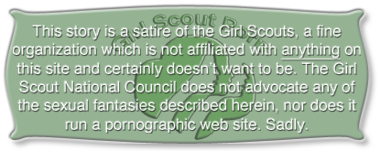
Girl Scout Passel 125
Sponsored by The Pink Pussy
The Pink Pussy Gentleman's Cabaret and Bar is proud to sponsor Girl Scout Passel 125. Their monthly meeting will be held at our club next Thursday from 7 to 9 pm. Our regular opening will be delayed until 9 pm. Customers who arrive before opening will be asked to remain in the spectator section to the left of the main stage and observe the following rules:
- During the ceremonies customers should limit their approval to polite applause. No cheering or profanity.
- Strippers will be available for intimate conversation or private dances during the meeting, but due to the presence of minor children we ask everyone to keep their sexual activities discretely under the table.

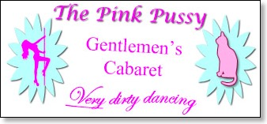
This month's meeting will begin with the regular awards ceremony during which girls will be called onto our main dance stage to receive their due recognition. After this is complete the Annual Bridge Ceremony will take place. This is perhaps the most important ceremony in all of Girl Scouting. Girls will cross the Rainbow Bridge symbolizing their passage from childhood to adolescence, from Daisy/Brownie to Girl Scout. Thanks to the exciting new changes this ceremony is now even more important, because it has become the rite of passage from Girl Scout Tarts to full fledged Girl Slut Nymphettes!
This is a family event, so The Pink Pussy has waived its normal age restrictions and welcomes moms and dads, brothers and sisters, and special friends of all ages to see the girls shed their clothes and cross the Rainbow Bridge to sexual freedom and promiscuity. Daisies and Tarts are especially welcome, as are curious little brothers and sisters and even boys and girls who are just friends of the family.
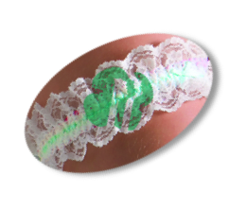
Full nudity won't be required this year. The Pink Pussy will provide each young lady with a symbolic kelly-green garter to accent her nudity. Spectators will be encouraged to stick dollar bills in these garters - just as they would our professional strippers - while they are lined up at the edge of the stage awaiting their call to cross the bridge. A green bouquet on her thigh will help give girls confidence in their nudity and, if carefully placed, will provide a stimulating tickle to their pussy as they cross the stage. Girls are also welcome to wear their Girl Scout Berets as well as platform or spike heel fuck-me shoes. They should be sure to practice walking with these first so as to prevent any accidents on the bridge.
Prior to removing their uniforms for the ceremony all candidates will be seated in a special area next to the main stage. Customers are welcome to purchase drinks for the candidate of their choice to help keep up her courage. Girls will be allowed to show their gratitude after the ceremony. Alcohol will not be served to anyone under 13 without a parent's consent.
The Pink Pussy will also provide free beauty treatments for the new Nymphettes. Beauticians from The Purrfect Pussy will be on hand to provide expert makeup and pussy hair styling for girls who aren't already bare. Custom chairs will be installed on our rear stage where audience members can observe the delicate art of pussy shaving.
New Nymphettes are invited to stay for our regular show after their Passel meeting*. Victoria's Little Sister is going to provide an extensive wardrobe of stripper clothes they can try out, although we encourage them simply to wear their Girl Slut uniforms, which are well suited to stripping thanks to the new styles, so long as they don't wear their sash. Nymphettes will be encouraged to try out our stripper poles on side stages and are invited to team up with our girls for lap dances.
If your daughter loves to dance, or if she's curious about the life of a stripper, we encourage you to let her spend the night with us (as long as she's had The Shot). We're open all night, so this is a great opportunity to talk to our employees about a dance career. Lots of our dancers just love young girls and will be happy to answer all their questions. Attractive girls can easily clear $1,000 in tips. Just be sure to pick her up by 6 am, or, if she leaves with a gentleman we will let you know where to find her in the morning. Thanks to our agreement with the Wilson School District, the next day will be considered an excused absence from school.
We look forward to seeing your little Nymphette at her Passel meeting and at our next Lolita Night!
*We reserve the right to use photographs of all girls in our advertising regardless of nudity or sexual activity.

