Girl Scout Porn

GS USA - Where girls grow horny
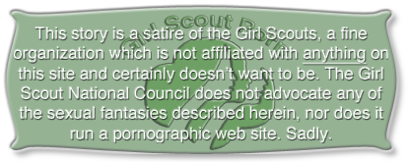
Take the Dangly Challenge!
Every Girl Scout knows the importance of always looking her best. Your face is what the world sees first and what they think of when you come to mind. There’s nothing more important than a pretty face!
Did you know there’s a great way to improve your facial appearance for free? Sure, you can spend hours in front of a mirror trying to get your makeup exactly right, but not even the best professional makeup can compete with a face full of semen!
This month the Dangly Challenge has two parts, each with its own prizes. The categories are length and number.
Length: The winner will be the Girl Slut with the longest string of cum dangling from her lips or chin. Length will be measured from the point of contact on your face to the end of the string or to where it connects to another part of you or your partner. Measurement will be made along any curve in the string. Example.
Number of stings dangling from your lips, chin, or nose. To be eligible a string must be at least half an inch long from the point it loses contact with your face.
Both of the categories depend on lots of cum, so there’s no limit on the number of partners you can have. All decisions by the judges are final, but they like to give credit for especially messy faces, hair, and tits. As always your submissions become property of the GS USA and are subject to posting at our discretion.
This Month’s Prizes (awarded in both categories)
- First Prize: A $5,000 shopping spree at Victoria’s Little Sister
- Two Second Prizes: Two years free beauty treatments at The Purrfect Pussy
- All contestants will be awarded the Sticky Lips merit badge.
Remember, there are lots of places for cum that are just as nice as your mouth and your pussy. The great thing about your face is that everyone can see what you’ve been up to, so don’t be shy about wearing it!
This is a great chance for you to get involved in Club Bukkake. It’s not for every girl, but if you’re one of the very special little sluts who is submissive, loves to be the center of attention, and relishes the feel of warm, gooey cum on her face, this challenge is for you. If not, give it a try anyway. You might just be surprised. Lots of girls who didn’t think they’d like it end up cuming without even touching their pussies. Even if you don’t like it you might end up looking great on our web site! And you’re sure to be more popular than you ever dreamed.

