Body Paint
The use of body paint is an exception to the Dress Code. This exception allows girls to use body paint as an alternative to clothing. As you can see, it can be done quite attractively, and modestly, as well.
World cup soccer girls:
World cub girls. The green and yellow girl has soccer balls painted on her butt cheeks. She is afraid to turn around, though, because there is nothing painted on her front.
World cup girls again. -- note the full frontal view of the American girl, showing that she is fully decent in spite of being naked:
Pants being pulled down has the advantage that she appears to be covered, even though her lips are not painted:
The body of the butterfly is left unpainted. However the use of color completely camaflauges any lack of decency:
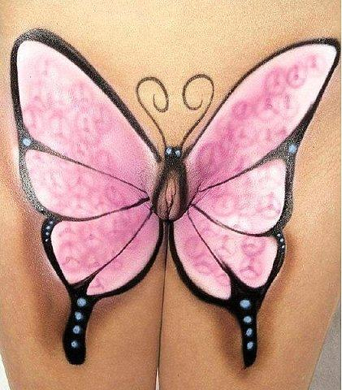
The painting of faces on the butts of these girls hides their private parts completely:
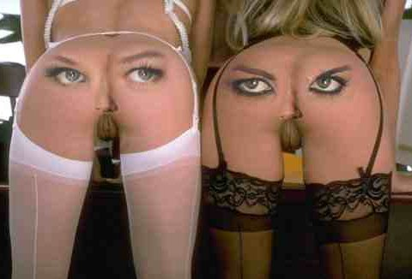
This boy's apparatus melds completely into the trunk of the elephant drawn on his abdomen:
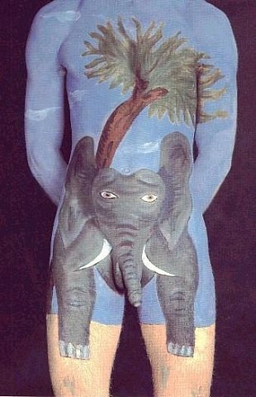
Girl being painted. Her lips are last to go, and they will be covered in due course:
From the rear, you can see her ass is fully covered:
All but the very pinkest parts of her lips are covered, as you can see from the rear:
Even squatting, you can see she's covered. Again, you can faintly see some pink between her lips, but by and large, she is fully decent:
Posing on her front steps, she is fully decent, and ready to appear in public (just building up the nerve!)
Beginning her stroll, she strides confidently, feeling naked and yet covered:
In the crowd, she remains composed:
Feeling more adventurous as she is accepted as clothed by the crowd, she parts her legs slightly (as much as she dares) and remains fully covered, as viewed from the front. (From the rear, her pinkness is visible, but she is unaware of that, even as she feels naked)
Another picture in the crowded area, showing her natural feeling of being fully clothed:
Legs akimbo, she remains composed:
Boys look at her ass, which is clearly naked, although she feels fully clothed.
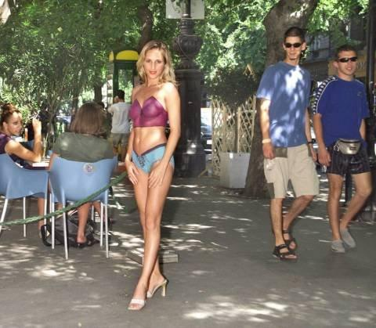
Feeling completely adventurous now, she is willing to spread her legs wider:
Tue Jul 19, 2005 12:49 pm MST by Richard Hertz | Email Article | |

