Ibz and 72 virgins???

By: SiCiAiT

siciait@hotmail.com

Fan Request

Part 1 of 2

Ibz and Sara have been going out for a few years now, Ibz feels he can be open and talk to Sara about anything, they keep no secrets from each other. Ibz has always had a weird fantasy, he's always been thrilled to the core by the idea of being a toilet, part of the plumbing that consumes the daily shit and piss, he has always wanted to tell Sara about how much he wants to serve as her toilet, but he could never build up the courage.

One day, after Ibz had been out, he came home, a little tipsy and he was horny. As he walked into the bedroom he saw Sara in bed sleeping. He decided it would be the perfect time to slip down to the den to get online to his favorite web site. As he switched his computer on, he stumbled about taking his pants down. He logs on and puts some headphones on to listen to the videos of mistresses using their slaves as toilets. The first one he clicked was Mistress D and what she expects from her slaves. No sooner did he click play Ibz passed out with his head hitting the desk with a loud bang.

Upstairs Sara sat up in bed. She grabbed the baseball bat next to the bed and went down the stairs to see what the noise was. As she sneaks around she notices a light coming from the den. As she slowly walks into the den. She sighed and relief, "Oh, Ibz it's you." She walks over to him and can clearly smell the booze coming from him. "Drunk again, why didn't you go to bed?" Sara reached over to turn off the computer. She stopped seeing a video playing of some lady sitting on a couch. "So what where you watching Ibz?" Sara slowly takes off Ibz headphones to listen to the video. As she listen her caring face went to a disgusting look. She could not believe what she was hearing. After watching the whole video Sara went back to the bedroom leaving the computer on and Ibz in the den. That night Sara didn't sleep, she loved Ibz but she was afraid.... this was just creepy and wrong? It can't be right what man wants to be a toilet? What was that lady talking about. Was that some kind of sick religion or cult?

The next morning Ibz raised his head and noticed the computer still on. "Oh shit, good thing Sara did not see this." Ibz hurries up and shuts it down and goes to the kitchen for his morning cup of Joe. As he was drinking his coffee he walked around the quiet house. "Sara you here. Hello." He walks up to the bedroom and opens the door. There on the bed laid a letter. "Went to Shelly house, Sara." Ibz scratched his head "Wow not even I love you." Ibz grabbed the pen next to the letter and wrote, "Went to work. I'll see you tonight. Love you Ibz." After Ibz finished his coffee he jumped in his new Mercedes and drove off.

Sara and Shelly was sitting outside at the local Starbuck drinking their morning cappuccino. "So what's bothering you?" Shelly asked, "Are you finally dumping that wimp of a man of yours?"

"After what I saw last night, I think I'm ready." Then Sara looked very disappointed. "But the money."

"What did you see? Was he try to fuck someone with his tiny prick?" Shelly asked giggling.

"That would be easier to handle. He is just into some sick shit."

"Come on spit it out. Was he jerking to some porn? What was it like, two fingers." Shelly said laughing out loud.

"Promise not to mention what I say to anyone."

"Of course, we been friends since 2nd grade and I never told anyone who your first kiss was, have I." Shelly grabs both Sara's hands. "Come on tell me."

"Well he was passed out at his computer again last night."

"Drunk again?"

"Yeah, well on his computer there was a video playing of some lady on this couch."

"Oh a porn movie I knew it."

"Do you want to hear this?"

"Yeah sorry." Shelly zips her lips and stares at Sara.

"This lady was on there. She was some kind of mistress. She liked to use her slaves as toilets."

"Eww, that is sick."

"The worst part of it, sounded like a Islam belief thing. The lady claimed if slaves died from eating shit that they would be blessed with 72 virgins of the sex that killed them when they raised to the heavens. He even marked it in his favorites."

"Oh that is creepy, sick. You need to dump his sick ass."

"But the money." Sara sighed. "He has me in his will if he ever died, but since we're not married I'll lose everything if I leave him."

"Girlfriend, you go back to that sicko and pretend nothing happen. Let me figure out the details."

"But what if he wants to have sex. I don't think I could do it."

Shelly reaches into her bag and pulls out a bottle of aspirins. "Safe enough to take, even if your faking a headache." she shakes them and hands them to Sara.

When Ibz finally came home he walked in and sets his things on the hallway table. "Sara you home?" He walked in the living room and saw Sara on the recliner. "Oh, there you are. Where did you go so early this morning?"

"Shh, lower your voice. I have a major headache. Shelly invited me for coffee this morning. Sorry I was not here." Sara covered her head with a pillow.

"I'm really hungry, I'm going to make something to eat."

"You should make a peanut butter sandwich." Sara lowered her voice. "It's almost the same thing you like."

"What was that Sara?"

"Oh, nothing I was just saying you should make a peanut butter sandwich."

"That sounds good I'll make one, after I'm done I'm going to bed want to come?"

"I would love to but this headache is just pounding and I'm afraid I'll keep you up all night. I'll see you in the morning." Sara blows him a kiss and place the pillow back over her head."

"Ok, love you sweet dreams."

Ibz ate his sandwich and went to bed leaving Sara in her recliner. By morning Ibz grabbed his coffee and went off to work leaving Sara to sleep. Around nine Sara woke to her cell phone ringing.

"Hello"

"Hey girlfriend. Good morning how was your night." Shelly asked all happy.

"My back is sore. I slept on the recliner all night. God I can't take to much more of this." Sara stood up to stretch her back out.

"Don't worry about a thing. I have it all worked out and you'll love it. I'm about ten minutes away. Oh, and have enough coffee on. I have some guys coming over to do a little remodeling. I'll see you soon, love you, bye."

____

That night Ibz walked into the house to the smell of freshly cooked lasagna. "Wow, it smells great in here. What's the occasion?"

"Welcome home. I thought since I was not so nice last night that I'll make it up to you. Go sit at the table I'll be right in with your dinner." Sara went back to the kitchen to grab the plates. "So how was your day?" Sara placed the food at the table and poured a glass of wine for Ibz.

"It was good. Wine, where is the good stuff?" Ibz asked taking a sip of the wine.

"I bought you a bottle of Jack but I was hoping we can have at least one Friday without you getting drunk. You can have it tomorrow, ok." Sara said kiss him on the forehead.

Just as Sara and Ibz was just about done, Ibz cell phone rang. "Don't answer it lets of a good night." Sara said putting her hand to his."

Ibz looks at the number. "It's my boss. I have to answer it." Ibz hits the talk button. "Hello ... Oh Hi Al ... What ... Why ... But it was not me ... You can't I have given you ten years ... Wait." Ibz boss hanged up as Ibz sat there in shock.

"What's wrong Ibz." Sara asked concern.

Ibz stood up and went to the kitchen. Sara sat there with a small grin on her face as Ibz walked back in with the bottle of Jack in his hand. Ibz sat back down and fills his shot glass to the top and downed it.

"Ibz you promised not until tomorrow."

"Look," Ibz pours another shot as Sara sat there watching him fill it to the top again. "I have just been fired from my job. So I don't give a fuck right now!" Ibz pours the shot down and fills another.

Sara watches him down one after another give an evil smirk. "So why did you get fired?"

"He said the report I turned ... in was done all wrong." Ibz starts to feel dizzy "The intern had to do it the right way ... and she is getting my job. Wow, this Jack most be really ..." Ibz falls to the floor out cold.

Sara grabs her cell phone. "Shelly he is out. He downed about eight shots."

"Eight! Oh my god, one shot would of put him out for hours. Ok will be right over."

Sara kneels next to Ibz. "It's funny I asked you not to answer your phone, but then you did anyways." Sara pulls Ibz shoes and socks off. She pulls his pants off. "Then I asked you not to drink the JD, but of course you had too." She rips his shirt right off his back. "Maybe next time you will listen to me." There was a knock at the door. "Time for your fantasy to come true Ibz." Sara gets up and opens the door. "Hello everyone come right in."

"So he is out cold?"

"Yeah I have been talking to him but not sure if he could hear me."

"That is the nice thing about this drug. He can hear everything. He just can't move." Shelly walks over and kick Ibz in the stomach. "Is that right you sick freak. Sorry Sara I have to see what was so good about him." Shelly lifts Ibz underwear up and looks down. "Oh my god, my pinky finger is bigger than that. How did you even do it?"

"Lots of faking." Sara kneels down again to Ibz. "So we have a game we want to play with you. You should love it. I want you to meet the ones that made this happen. You know Shelly and her boyfriend Jason.

"This is going to be so fun." Shelly said jumping up and down.

"I feel sorry for you, you sick freak." Jason said spitting in Ibz face.

"Then we have Kenny. He is a handyman. He is going to make this game as real as possible." Kenny gave a thumbs up and grabs his tool box and walked to the back room. "I have been wanting to tell you this since you started your job, but was too scared to let you know. Anyways there is Al your boss. You see he was my very first kiss and well we have been seeing each other behind his wife's back. So know that we're all introduced, guys grab his feet and drag him to the back room."

As the two guys grabbed a foot and started to drag his body down the hallway Shelly runs up behind them. "Hang on guys I have to do something." Shelly goes down the hallway some and then turns and starts running back to them. As if reading Shelly's mind Al and Jason steps back spreading Ibz legs apart. Shelly kicked Ibz between the legs like she was kicking a field goal.

"Oh my god dude, he did not even whimper, did he even feel that?" Al said dropping Ibz leg.

"Yeah he felt it alright, but he can't even move a muscle with all the drugs he drank down. Wow that felt good you want to try Sara?"

"No, not right now I would rather hear him scream."

They finished dragging Ibz into the backroom. In the room was a bathroom toilet and the sink. They dragged Ibz into the bathroom where there was a hole three foot by six foot with concert walls and was flush with the floor.

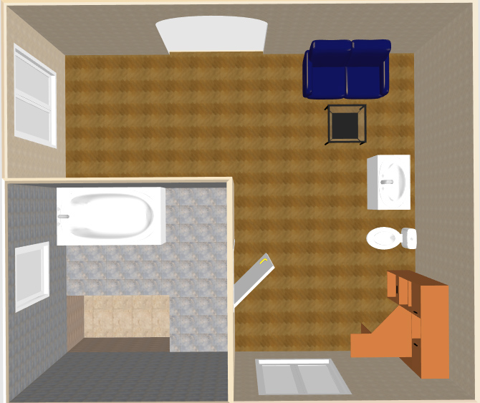

In the hole was two pipes flush with the floor of the hole They dropped Ibz into the hole. Al hoped in the hole and strapped Ibz legs, arms, and head down. Sara and Shelly sat on the bathroom floor with their feet inside with Ibz.

"So do you like the remodeling my friend Kenny did?" Shelly said smiling ear to ear. "I think you'll like this game."

Kenny jumped in the hole and attached an extension to pipe in between Ibz legs. "So that connects right to the sink and we would not have to change anything." Sara asked.

"Nope" Kenny said as he finished setting the pipe. Kenny build a wood frame over half of Ibz body and laid the bathroom floor tiles. Then he bought in the bathroom sink and hocked it all up.

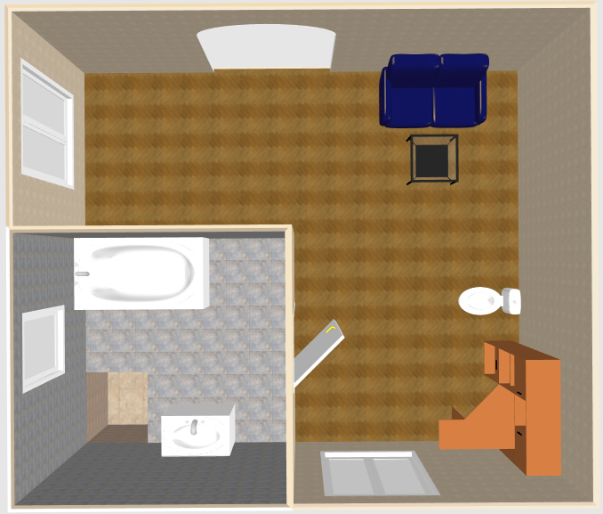

"So can you figure out what the game is going to be?" Shelly asked Ibz with a big evil grin. "Sara wanted to tell you the rules. Go head Sara he is all yours."

"So you think if you die eating shit you would get 72 virgins? We are going to test that theory. After I tell you the rules Kenny is going to connect a pipe to that smelly mouth of yours that he created himself. It well route all the water down the sewer and everything else will go into your mouth. So the rules is this the rest of this week you would be my toilet. You better hope you die before Saturday, because we all decided to throw a big party. You better hope you don't get used by a man and die. That would suck if you get 72 virgin men." Sara started laughing uncontrollably. "Thank you for putting me in your will. That way this house well stay with me." Sara reached down and connected a pulse oximeter to Ibz finger. "I'm not sure if you can see it but in the corner of the bathroom is a very small camera. This way if ... I'm sorry when you die we will be able to see who killed you. When that happens they get a prize." Sara started to laugh, "They well not even know what they did to get it. Unless it is one of us. He is all yours Kenny." Sara stood up and blow a kiss to Ibz and waved good bye.

Kenny hocked up his makeshift pipe to Ibz mouth finished the frame over Ibz body and laid the rest of the tiles. Al carried in the toilet and Kenny hooked it up to the pipe in Ibz mouth. They all walked in to see Kenny's finished job.

"Wow you can't even tell Ibz is there." Sara said extremely happy.

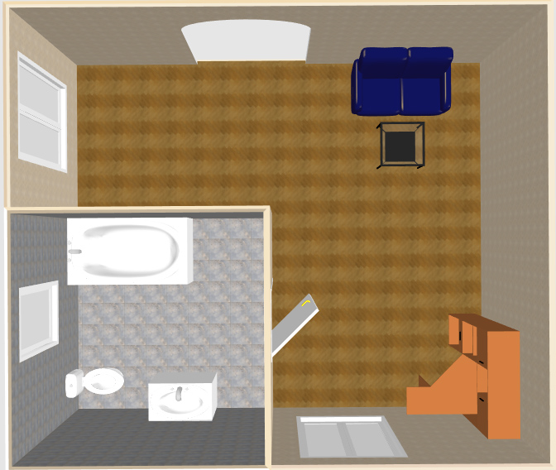

"I hope you like your new bathroom Sara. See you Saturday" Shelly said as she walked out of the house with Jason.

"I'll be back Sunday to finish up." Kenny said as he put his tools in his truck and drove off.

"So what should we do? I don't have to be home until nine." Al said smiling at Sara.

"I don't know about you, but seeing all that just got me hornier then hell. I'm going to the bedroom." Sara grabbed Al's hand and walked back into the house.

Al and Sara stripped down and started to make love like they never have done it before. She sucked on Al's dick for over ten minutes. She wanted Al bad, but she was getting more horny think of the fear Ibz was having being in that dark coffin waiting for that toilet to flush. As Al was getting ready to blow Sara stopped. She got into doggy position and smiled back at Al.

"What ... are you sure?" Al asked, "You never liked anal."

"I figure it this way. Liquid goes down to the sewer and if I want Ibz to taste the fun I'm having I would have to hold it in tell tomorrow so it's all mixed together." Sara just had an evil smile on her.

It did not take long for Al to blow as he was pumping in and out. Sara had an orgasm like she never had. Just as Al started to pull out as Sara squeezed her ass cheeks together and laid on her stomach. "Oh my god, that was great. I hope all that cum don't give me the runs. I wish I could see his face when he tastes it tomorrow."

When Sara fell asleep Al kissed her good night and went back to his home. Sara slept like a baby and the whole time she slept she had a smile on her face. When morning came Sara walked into the kitchen and pour herself a cup of coffee. As she sat there she could feel the pressure building up inside of her. She sat there sipping her coffee, "Almost time to use my new toilet." Sara said out loud smiling to herself. Sara grabbed her phone and dialed 911.

"911 state your emergency."

"I like to report a missing person ... It's my boyfriend Ibz ... Last night he was fired from his job and left and never returned home ... I'm afraid he might done something ... He has always came home this has been the first time ... ok I'll wait here for them to show up ... thank you." Sara poured herself another cup of coffee. She could feel the pressure push at the exit. "Not yet. We have to talk to the police, Then I'll let you out."

Fifteen minutes later the door bell rang. Sara answered it and talked with the police officers. They asked her a bunch of question. One officer gave her a hug as Sara started to cry. They told her that most of the time when people work for a company for as long as Ibz they feel their life is over, but they will keep looking and call if they find him. As they walked out of the door the other officer picked up the morning newspaper on the front porch and handed it to Sara.

Sara started to cry harder, "Ibz usually grabbed this very morning before he went to the bathroom."

"Maybe you should put it in the bathroom for him. Just in case he shows up." the officer said patting her back.

"That is where I was headed before you guys rang the door bell. Thanks for your help. Please find him and bring him home."

___
Sara closed the door behind her and smiled to herself as she looked at the newspaper in her hand. "Well at least I have something to read as I take care of business." Sara walked down the hall to the bathroom. As she walked in she checks the oximeter. "Nice, looks like my toilet is in prefect working order." She pulls her tight jeans down and lowers herself to the toilet. She sat there looking through the newspaper as she let her pee flow in to the toilet. "Oh Ibz, if only you weren't such a freak maybe you would not be in this predicament. Here comes your breakfast." Sara pushes and lets out a huge fart. "Did you hear that Ibz? It sounded like my asshole called your name." Sara starts giggling as she let a long log slip out and slash into the toilet. She continued to read the paper as she pushes another log into the toilet. "Oh my god that is perfect!" Sara wiped her ass and without a second thought flushed the toilet and ran out of the bathroom.

Ibz was laying there in complete darkness and heard something rumble though the pipes. "Did she just fart." He thought to himself. His jaw was sore from being forced open all night long and his mouth was dry. Ibz has been trying to free himself all night but could not move any. "How did this happen? I always wanted to be used as a toilet but never like this." Next thing Ibz heard was water running down the pipes. In a few seconds something went into Ibz mouth. Then something else hit against the thing in his mouth pushing it into his throat. Ibz swallowed to avoided chocking but as he swallowed the first piece the second followed right behind with a wad of toilet paper. Ibz started choking and was losing oxygen as the oximeter started to go off. Ibz did all he could to swallow hard. As he finally cleared his throat he began to breathe again.

"I don't know the oximeter is going off. That's going to suck if he is dying already. The weekend has not even came yet." Sara was talking to Shelly on the phone. "I guess I'll go check." Sara began to walk down the hallway when the alarm on the oximeter stopped. "Well I guess he is breathing again oximeter stopped. So anyways did you read the paper this morning? A man was hit by a train last night. It says they can't identify the body. Do you think I should call the police back and tell them it was Ibz?"

"No wait for them to come. It would make it seem you want him dead. Just wait, they will come." Shelly told Sara.

The rest of the week Ibz was in hell. With complete darkness and no sound from the outside world Ibz was going insane. He knew when morning came because Sara was like clockwork. Every morning she fed him her shit, but what was worst is the amount of toilet paper that passed into his mouth and down his throat. It seemed that Sara was pissing every hour. Ibz had a hard time with this. On one hand he always wanted Sara to use him as her toilet but on the other hand he never imagined it to be like this. He had to swallow this one piece down that was so hard that it would of been easier to swallow a rock. Every once in awhile he could hear a faint banging from the floor and sometime later the toilet would flush.

"Hey loser!" Sara starts stomping on the floor. "I hope you choke on this one! At least if you die on my shit you'll get your 72 virgin women but tomorrow the real game begins." Sara flushes and walks out of the room.

Saturday came and Ibz waited for his morning routine but this time when the toilet flushed nothing came into Ibz mouth except more toilet paper. Above Sara starts talking think Ibz could hear her. "So I decided to wait until tonight to feed you. I can't wait to see how long you could last." The door bell rang and Sara hurried out of the bathroom to the door. As she opens the door she sees the two police officers that made out Ibz missing person report.

"Sara ... we have some bad news. There was a train accident last Monday. We were unsure at first who it was, but we identified tattoos on what we could find on the picture you gave us. We are sure Ibz ... was hit by that train."

"Oh my god." Sara put up a good act as she fell to her knees crying. "Are you sure it was Ibz?"

"I was afraid to show you this but was this Ibz tattoo he had on his arm?" The Officer handed Sara a picture.

Sara looked at the picture and could not believe what she saw. There was a piece of skin stuck to the train with the same tattoo that Ibz got when they first met. "Oh my god Izb!" Sara started to cry more.

"We are sorry for your lost. If you're up to it Monday please stop by the station so we can do some of the paperwork. Is there anyone you want us to call?"

"My friend Shelly is coming over shortly. I'll be alright until then. Thank you." Sara closed the door slowly. Once the door was closed Sara started dancing around real quietly. Sara peeked through the window and watched the police officers drive away. As soon as they turn the corner Sara yelled out. "Yes, Izb dead." She looked down the hallway. "Well almost. We still have a game to play."

That night as the party goers began to show up, Ibz was able to hear muffled noises. He was not sure what was happening but he was a little worried. "Shit it must be the party Sara mentioned. Is it Saturday already? I hope Sara lets me out Sunday." Ibz thought to himself.

"Everyone can I have your attention." Sara yelled over the crowd of partiers. "I have some bad news. I was not going to have this party but I needed to be around people right now." Shelly looked at Sara questionably. Sara continued, "You see Ibz has been missing since Monday and this morning I just found out that he was hit by a train." Sara began to cry.

Shelly ran up to hold her and whispered into her ear. "What are you doing?"

Sara whispered back, "Play along I'll tell you later." Sara turned back to the party goers, "The last thing Izb did is remodeled our backroom. There was this silly thing he did. He rigged the toilet to sound a buzzer after a certain amount of times that the toilet was used. I don't know what the count is but he claimed the winner gets two hundred dollars. So to remember Ibz I am keeping his wish. If you can get the buzzer to go off you WIN. Let this party be for our dear friend Izb for the man that made the toilet into a game."

Everyone raised their beer, "To Izb, may he rest in peace."

Shelly pulled Sara to the side, "What is going on?"

Sara used a handkerchief to dry her on tearing eyes and gave a slight grin to Shelly. "The guy that was hit by the train had the same tattoo as Izb. So we are in the clear. Also I changed the settings on the monitor. He will have to stop breathing completely for four minutes. Let the game began."

Shelly hugs Sara as if giving her confront, "Oh my god, I am so glad for you."

Al walked over to Sara and gave her a hug. "So how about you and I go to the back bedroom and remember the good old times."

Sara reached up and gave Al a kiss on the cheek and a hug as she whispered into his ear. "I want you badly, but right now we have to stay cool until after Monday." Sara did a growl in Al's ear as she walked away swinging her ass at him.

Meanwhile people were coming in and out of the toilet and every time Ibz heard the toilet flush he could feel his heart stop. Someone used so much toilet paper it almost clogged his throat but he was thankful nobody took a shit. Izb was not as lucky as he thought. The first person to use him was Dee. She was over two hundred pounds and was not all fat. She was one of those girls that could walk into a biker bar and take on any man and watch him get hulled away in an ambulance. She walked into the bathroom, looked into the mirror to pick at her teeth. Then she pulled her pants down and lowered her ass to the toilet seat. She pissed for what seem to be five minutes with such force that Ibz could hear it hitting the water. Then she let out such a huge fart that Ibz could hear the water pushed down the drain and he could swear he could smell it. Dee pushed and out came a log about ten inches long that never broke. She stood up without wiping her ass and pulled her jeans back up.

She turned to look at her handy work, "Wow, that is a nice one. That should be a winner." With that she flushes. She waits a few minutes to see if she was a winner but no buzzer went off. She got so mad she ripped open the door and started pushing people that were waiting their turn. "This game is rigged! I'm going to the bar."

Ibz hears the toilet flush and within minutes the shit hit the back of his throat. He used his tongue to push the shit away from his throat and as his taste buds touched it he retracted it back do to the fowl taste. As he did that, the shit fell further down his throat. Ibz reacted by swallowing, which he did not want to do. Ibz felt very sicken by that piece he thought for sure it was a man that did it.

The next person to take a shit was Mike. Mike was one of those guys that the girls thought he looked like Brad Pitt. When he walked in he pulled his pants down and unload his shit. The shit piled up on top of each other. When he finally was done it was above the water level. He wiped his ass and flushed it down.

As Mike opened the door he spooked out, "Ibz should have put a fan in there. Sorry everybody."

The next person walked in, "Holy hell dude! What crawled up your ass and dead?

"Enjoy Tom." Mike said smiling back.

The night went on and Ibz was eating shit from a bunch of people. His stomach was getting packed good there was at one time a women used him that had a shit that was so wide but short that it got stuck in his throat. As he was choking on it and having a hard time breathing a guy used the toilet that hand a solid and long shit that it pushed the wide shit down his throat. Ibz could feel it tearing down his throat but was glad he could breathe again when it finally went all down. By the end of the night Ibz had shit packed all the way just below the epiglottis.

After everyone left Sara, Shelly, Al, and Jason walked in to the bathroom. "I can't believe it he is still alive." Sara said disappointed.

"Are you sure the monitor is working correctly?" Shelly asked Sara.

"Yes look." Sara opened the cabinet that had the oximeter in it.

"He still has one more day." Al said shrugging his shoulders.

After everyone left for the night, Sara went to sleep thinking about everything she is going to do with Al when everything is done with. By morning Sara was woken up by a knock on the door. Sara looked out the window. "Oh shit!" Sara put on a sad face and forced some tears out as she opened the door.

"Oh my god, I'm so sorry, I was going to ..." Sara was letting the tears roll down her face.

"You don't have to be sorry dear. Izb was a good boy and you took good care of him and I'm happy that you became my daughter-in-law." Ibz mom gives Sara a hug. "So how are you holding up?"

They sat and talked for hours drinking coffee. When Ibz mom asked, "So are you going to be alright if I leave? I have things to do before the funeral."

"Yes, Shelly and some friends said they would stop by today."

"Do you mind if I use your bathroom before I leave. Coffee seems to push things down first thing in the morning."

"No, not at all. You could use the bathroom in the backroom."

As Ibz mom walked down the hallway, Sara peeked around the corner to watch her close the door behind her. Sara just had a wicked grin on her face.

As Ibz heard the toilet flush a huge shit forced its way into his mouth. This shit was too much for Ibz to handle. The weight of it kept pushing in and down his throat. It was cutting any chance for Ibz to breath. As Ibz mom walked out of the bathroom the oximeter buzzer started to go off.

"What the heck is that?" Ibz mom asked.

"Oh my god, I almost forgot that when Ibz remodeled this bathroom he set up a counter that would go off after a certain amount of users."

"That sounds like something Ibz would do." Ibz mom smiled. "So what do I win?"

"Ibz said the person would get two hundred dollars. I guess you won." Sara handed her the money.

Ibz mom laughed out loud. "Wow that was one expensive shit. For that much I would of done it in someone's mouth." Sara started to laugh out loud. "That's it dear. You need to laugh. It helps. If you need anything and I mean anything just give me a call. Love you sweetie."

As Ibz mom started to walk out the door Shelly, Al, Jason and Kenny were walking up to the front door. Ibz mom gave everyone a hug. "You guys were Ibz best friends. Please help Sara with whatever she needs." As she got in her car she rolled down the window. "Hey I forgot I won two hundred dollars for taking a shit, Bye."

Shelly covered her mouth. "Holy shit you had his own mother kill him?

"What can I say, she had to go."

"You are so cruel." Jason spook up.

Sara turned to Kenny. "He's all yours." Sara gave Al a hug and a kiss.

Kenny made a call and went to the backroom. He removed a tile above Ibz and had to leave the bathroom. "Holy hell, someone needs to bring in a bunch of fans. It smells like a backed up septic tank in here." Everyone came in with fans plugging their noses.

"Shit Ibz you stink." Sara said.

A few minutes later they heard a big truck pull up to the house. "Good it's here." Kenny said. Kenny walks outside and in a few minutes comes back in to the bathroom with a big long hose. "OK, HIT IT!" in minutes the hose started to pump cement into Ibz coffin. As it was pumping Kenny undid a tile by Ibz's face and disconnted the tube that separated the solid from water and connected a straight pipe to the sewer. Then he attached the hose to the pipe in Ibz's mouth.

"Al go tell the guy to put the pressure on high."

"Why are you connecting it to his mouth?" Sara asked.

"This way you don't end up with a pocket in the cement when he rots." Kenny said smiling.

Ibz blinked his eyes. "Where am I?"

An older lady about in her 50's reached out a lifted Ibz up. "Are you alright?"

"Yeah for second there I thought you were my mom."

"No young man, I'm not but ..." The lady lead him into a room

Ibz eyes went wide. "Oh, no not again!"

Before Ibz had a chance to run he had a bunch of people grabbing him and forcing him down in to a hole.

"You see young man. You get what you wanted. You get your 72 virgins but you get the likeness of the one that killed you. You will be forced to eat and eat all the shit you can handle and when you die you keep wakening back up here."

"But you are all old! Who killed me!"

"You're mother."

The End

Please Reply
By: SiCiAiT
siciait@hotmail.com

