Supergirl’s Cumming of Age
Story and Art by Scatwoman@aol.com

Chapter 4: “Supergirl’s Liquid Lunch!”

"Tsk-tsk-tsk," Power Girl sighed rubbing Supergirl's bloated belly. It was bulging from the combined mass of the various awful things she'd had forcibly pumped into it today. Krypto's super-doggy jizz. Power Girl's power-shit. And now Comet's fully bladder of hot, steaming, concentrated piss.

"No, this won't do," Power Girl shook her head in disapproval, "We can't have a fat Supergirl flying around! You need to set an example for all the stupid little blonde-haired prissy bitches out there!"

Supergirl had no idea where this was going, but she knew it wouldn't be good.

Power Girl nodded decisively, "Yes, I think we're going to have to put you on a liquid diet!"

She started stroking Comet's cock as she leaned in close and locked eyes with her captive teen toilet slave.

"In fact, no real food for you again until you've dropped some pounds, young lady!" Power Girl sneered.

As Power Girl stroked Comet's fat cock, Supergirl felt it growing in her mouth. In horror she realized it was getting even THICKER! It stretched her jaw before, now it was inflating inside her and there was nothing she could do about it!

Worse yet, Power Girl started pushing Kara's head forward on the stiffening horsedick, forcing her to orally service her own horse! It was BEYOND humiliating.

"MMmm, that's so pretty," Power Girl admired the view.

Slowly but forcefully, Power Girl worked Supergirl's mouth further and further up the burgeoning shaft. And it only got longer, fatter and harder as the girl was forced to suck it.
"That's it, show Comet how much you appreciated him letting you be his piss bitch and guzzle down all his yummy pee," Power Girl encouraged her, "give him a nice, deep, loving blow job like the animal-fucking whore you are!"

Power Girl worked Kara's head faster now, deeper still, over and over again until, with a sudden jerk, the fat, flanged head popped past the back of her throat and lodged itself in the girl's esophagus! Impossibly, improbably, but undeniably

her throat somehow expanded to allow the flared head to push through. She jerked and flailed at the feeling of being trapped on this massive horse cock stuck in her throat. Her eyes went wide with panic and Power Girl knew what must have happened. She could see the girl's throat bulging from the mass and the sight made her pussy drip with perverse excitement.

"Oh, FUCK yeah!" Power Girl's eyes went wide, "Take that fat dick into your throat, girl! You think Krypto's dick was big wait until you feel this monster bottom out in your pretty little face!"

Supergirl tried to scream, but all she managed to do was to constrict her throat muscles, tightening her oral grip on the embedded member. It responded to the pressure and grew even fatter as it engorged with blood! Supergirl thrashed impotently, instinctively trying to get away from the invading oversized animal prick, fearing the head might NEVER come out, especially not at this size! She'd be trapped on it until it blew inside her and flooded her guts with gallons of horse cum! Only when Comet was fully satiated would that monster head deflate enough to be able to squeeze back out!

However, as Supergirl discovered when Power Girl pushed her head even harder on the massive, stiffening horse cock, the bulbous head had much less trouble going *further* in!

"Oh GOD! Yeah! Fuckin' SUCK that horse dick, you filthy little WHORE!" Power Girl spat as she drove Supergirl's head ever more forward. Supergirl gagged and jerked, but there was no denying the fact that she was making slow, steady progress as inch after inch of throbbing, meaty horse meat disappeared between her obscenely stretched, pretty pink lips!

"You are SUCH a fucking natural at this, Superslut!" Power Girl complimented the orally-impaled nymph, "You're going to take it down to the ridge!"

Supergirl groaned as she felt more and more of Comet's fat prick slide into her mouth, over her tongue and down her gaping throat. It was coated with a kind of oily residue that builds up inside the sheath and needs to be cleaned regularly or else it becomes a truly foul smegma. Luckily for Kara, it was still just oily and slimy, not the worst thing she'd had forced down her throat that day!

Harder and harder Power Girl pushed on the bound teen's head, driving inch after unyielding inch into her unbelievably stretched mouth. Supergirl felt the flared flange descending deeper and deeper into her, stretching her esophagus obscenely and making it impossible for her to breathe.

At the same time, Comet's dick was STILL working at reaching its full length and girth. So not only was she getting horse dick shoved in from the outside, what was already INSIDE was getting bigger and longer as well, pushing the fat glans even deeper into her. She had NEVER felt so full, so stuffed, so TRAPPED in her entire life! But bound as she was and chained with kryptonite bonds, she could do nothing to resist the unrelenting rape of her mouth by her own Superstallion, Comet. She wondered if he knew what was happening, if he was taking any pleasure in doing this to her.

Almost as if in response, Comet's dick jerked powerfully inside her. Supergirl groaned at the feeling. It was one thing to feel its mass inside her, it was yet another to be reminded of the power of the massive organ as it throbbed and came alive in her. She could only imagine what it would be like to be fucked by such a monstrous organ!
She almost felt jealous of the mares Comet must have mated with... until she remembered that there are no other super-horses on Earth - no horse that could ever take the punishment Comet would dish out in his passion. Just as superstrong people needed other superstrong people to mate with, Comet would have needed a superhorse!

She immediately felt bad for Comet, a horse with no possible mates! In fact, just like Krypto! No wonder they were so willing to use HER... at least she could take them! Now she knew why Krypto had been so horny and aggressive with her that morning... and why his load was so incredibly massive - he'd probably been holding it in for who knows how long! And Comet! Why, this might have been the first time he'd ever had sex with ANYTHING! In a way, Supergirl felt honored by this thought. She loved Comet and she was actually happy that she could give him an experience like this for the first time.

"Oh SHIT!" Power Girl's outburst snapped Supergirl out of her reverie and she realized the pushing had stopped. Then she saw why. Her lips were now firmly pressed against the thick ridge near the base of Comets shaft. The rest of it, the other wide foot or so, was fully buried in her coaxing, undulating throat.

"You fucking DID it!" Power Girl exhaled in disbelief, "You actually deep-throated that entire fucking horse cock down to the ridge! I don't think even *I* could do that, and I've taken some truly monster cocks in my time!"

Again Supergirl felt a swell of pride as she flushed in embarrassment - both from the compliment and the nature of what she was being commended for...

"I have to see that again!" Power Girl grinned broadly as she slowly pulled Supergirl's head back. Her eyes got wider and wider as she saw how much MORE dick was coming out than went it, "Jesus Fucking Christ, kid! You must be the best fucking cocksucker in the galaxy! Comet's REALLY huge!"

When every last possible inch of horse dick had been retracted without popping the head back out of her throat, Power Girl put her forearm up to what managed to stick out between Supergirl's lips and Comet's ridge. The cock was easier the longer of the two.

"Good fucking GOD..." Power Girl looked up at Comet in awed appreciation, "that's the biggest horse dick I've EVER seen! Well, except one..."

Supergirl wondered what kind of mythic beast Power Girl could possibly be talking about, but she didn't have much time to ponder, as the busty super woman immediately shoved the girl's head forward roughly, implanting the entire foreshaft back into the girl's throat with a single, powerful trust!

Supergirl's eyes shot wide and tears ran down her cheek uncontrollably as Power Girl ground her head at its full depth, making the girl massage Comet's shaft ridge with her perky pink lips.

Then just as suddenly, Power Girl yanked on Supergirl's head and pulled it all the way back again. Then shoved it all the way forward again!

Power Girl was using Supergirl's face to give Comet the power-blowjob of his life!

"TAKE IT! TAKE THAT FUCKING HORSE DICK, YOU FUCKING MOUTH-CUNT ANIMAL-FUCKING SLUT!!!" Power Girl growled angrily as she pistoned Supergirl's head back and forth harder and harder, faster and faster.

Supergirl could to nothing to slow the rhythm, all she could do was go limp and ride it out, letting Power Girl use her as savagely and violently as she wanted. Her eyes rolled back in her head as she relaxed like a ragdoll, feeling the fat head plunging in and out of her esophageal depths like an oil well pumping for gas. Only at the end of this excavation, a whole lot of liquid treasure was going to be pumped IN, not OUT!

Power Girl worked the pace up to a blinding speed, using her super-strength and super-speed to make Supergirl give Comet the deepest, fastest, roughest blowjob the face of the Earth had ever seen. Her head was literally a blur as Power Girl pounded her back and forth on the erect horse cock, engulfing and releasing the full length of the stallion's super-shaft 10 times a second!

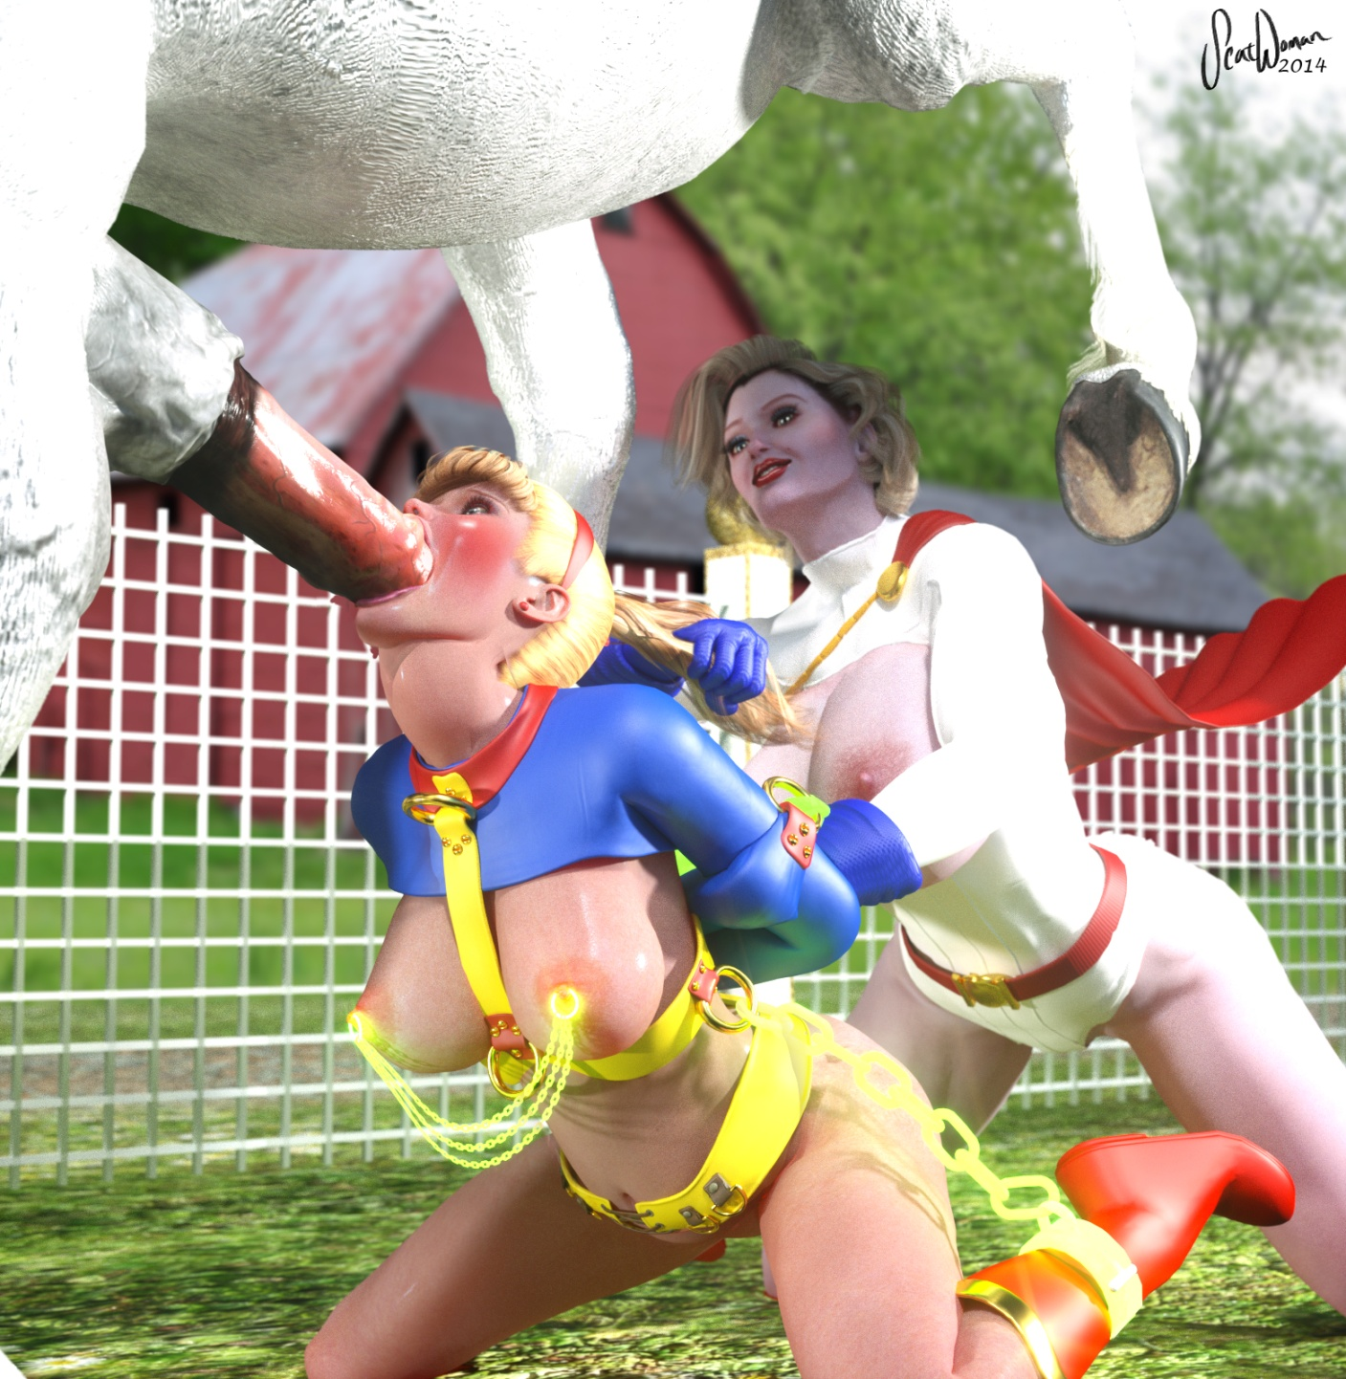

Supergirl couldn't think at this rate. The cock plunged in and out of her throat so quickly it was completely overwhelming. She lost all conscious thought and became nothing more than a hole for her horny horse's throbbing, aching cock.

All of this proved too much for poor Comet as well as he whinnied and neighed and drove his cock forward with such force that it nearly knocked Supergirl over and Power Girl along with her! His hard phallus slammed into Supergirl's face, nearly concussing the poor girl!

"Mmm, yeah," Power Girl purred, regrabbing Supergirl's ponytail firmly to hold her head in place as Comet began to face-fuck the captive teen, "FUCK this bitch right in her slut mouth, Comet! GIVE her that huge horse dick!"

Power Girl ran her free hand appreciatively along Comet's muscular body, down his shanks and then to his throbbing, veiny shaft. As he pumped Supergirl's locked-in-place face, Power Girl's hand added some extra stimulation, stroking and squeezing the base of the shaft where even Supergirl's lips couldn't reach.

"Yeah, that’s a good boy!" Power Girl urged the rutting stallion, "FUCK this bitch's throat! SEED her slut belly! Make her mouthpussy your filly!"

Supergirl groaned at the lewdness of Power Girl's creative mind and her whole body shook with each powerful thrust of Comet's fully engorged cock plowing into her oral depths. He was using the full force of his powerful hindquarters to pump Supergirl's face without mercy or consideration for her safety. And being a super-HORSE, he was much stronger than either Kara OR Power Girl. Supergirl was getting the FUCKING of a LIFETIME... it would have been an epic power-fuck even if it hadn't been a super-stallion's oversized horsecock plowing her petite face... but the fact that it WAS all of those things made it all the more an intense, unforgettable and life-changing event for the young teen.

"Holy FUCK!" Power Girl gasped, "Look at the SIZE of those BALLS!" Comet's already large horse testicles had now swollen greatly out of proportion - fully three times their normal size!

"That's got to be the biggest load ever, Super-slut!" Power Girl grinned as she cupped the enormous, distended balls, "I hope you've still got some room in that stuffed tummy of yours! Looks like Comet's got the load of his LIFE saved up in here!"

Supergirl swooned at the thought. Power Girl was probably right. This was probably the FIRST load Comet had EVER shot, being too powerful to mate with normal Earth horses. This would be his very first equine ejaculation... and Supergirl was going to get ALL of it, pumped directly into her already bulging belly! The thought was just too intense for Kara and she flushed with perverted arousal at the honor and sheer kinkiness of what was about to happen. Her pussy glowed hot and dripped uncontrollably. For the third time that day, Kara started getting that tingling feeling that started deep inside her virgin, hairless pussy and radiated outward like an electrical shock to every last nerve ending. She was going to cum, AGAIN, and there was nothing she could do to prevent it. What was WRONG with her?!!

Power Girl noticed Supergirl's state of extreme arousal and grinned in deep satisfaction at what she had turned the girl into in one short day.

"Yeah, look at you, you fucking worthless little SLUT," Power Girl berated the flushing girl on the edge of her first oral equine orgasm, "you can't WAIT for Comet to blow his horsie wad into your greedy little bitch-belly! You're going to cum like a little mewling pussy the second that first blast hits your gut, aren't you?!!"

Supergirl flushed deep red and mewled at the verbal humiliation being heaped upon her on top of the already deep deprivation of her equine mouth-raping.

"You're just a no-good horse-cock-sucking mouth-whore," Power Girl railed on without an ounce of compassion, "You're not good enough for sex with real PEOPE, only dirty ANIMALS! You're nothing but a lowly fucking useless toilet. You LOVE it, you're such a filthy whore!

Supergirl could only whimper in response. It was true. It was ALL true. She WAS nothing more than a total, shameless slut now. Her mouth has been used and abused in every way imaginable that day and she had come like a crazy woman each time. She was a bitch for dogs, a living toilet, a sewer mouth, a gutter-gut, and a depraved, worthless horsecock sucker!

"Come for me, Superslut!" Power Girl demanded, "You know you WANT to! Cum for me like the BITCH YOU ARE!!!"

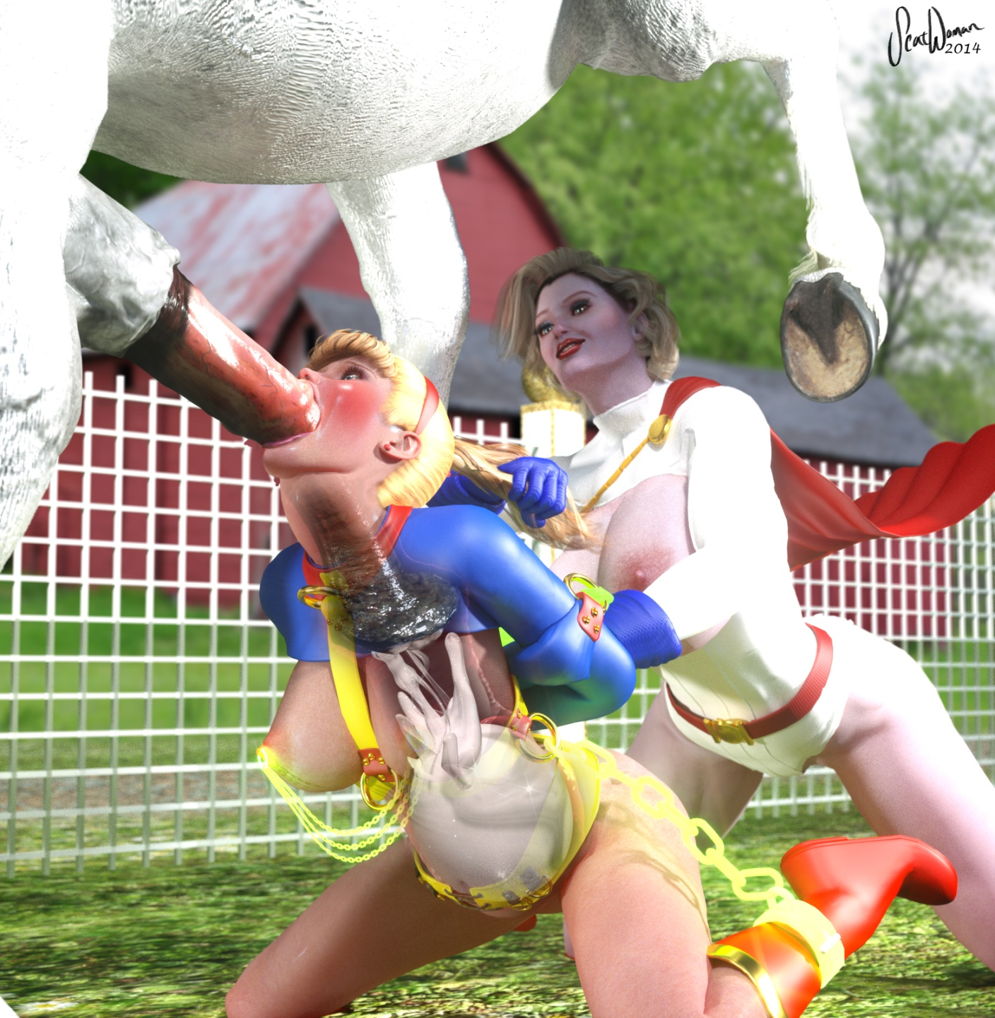
When Comet came, Smallville residents swore there had been an Earthquake, and people as far away as neighboring Granville felt the tremors.
The first explosive blast from Comet's engorged balls blasted down his long shaft like a rocket, exploding into Kara's belly with such force it staggered her AND Power Girl. Then he thrust so hard he knocked Supergirl right out of Power Girl's grasp. Power Girl had to get behind Supergirl and brace her with her full body to keep her in place to be face-pounded by Comet's Earth-shattering pistoning. The ground shook and cracked, animals scattered, birds flew away, hay bales tumbled and the windows on the Kent farm rattled and cracked from the force of Comet's purely animal-instinct face-fucking savagery!

And though Kara barely held on to consciousness, she keenly felt with every nerve of her being the thick hotness of Comet's super-stallion seed as it burst into her aching belly. And that exquisite feeling put her right over the edge, toppling off a cliff of control into a bottomless pit of ecstasy. As powerless to fight the feeling as she was powerless in her kryptonite bondage, Supergirl let herself fall, giving in willingness to the abyss. A deep, yawning, dark desire arose in her and consumed her as she shook, shuddered, rocked and quaked with her third mind-blowing orgasm of the day. And again without anything ever even so much as brushing against her yearning clit and pulsating pussy. She was becoming an oral dumpster for all things animal and offal. And she couldn't help but love every second of it.

Comet thrust powerfully into her face with each enormous gush of thick, potent horse jizz that thundered down his shaft into his owner's bloated belly. If he had any love for her or concern for her, it didn't show. All he cared about right now was cumming as hard and has much as he possibly could, filling his bitch with enough seed to impregnate her for TEN champion sirelings! For all he knew, he was a stud and Supergirl's mouth was his mare and he was going to breed her belly with everything he had!

After the first ten or so truly massive ejaculations, Comet's thrusting subsided and Power Girl was able to come back around and get an eye on the action. Comet's balls had deflated to half their largest size, but still quite oversized. He still had plenty of stud seed coming she realized with salacious satisfaction.

"Oh, wow, he's STILL cumming down your throat, isn't he?!" Power Girl marveled at the steed's virility, "What does that FEEL like?!"

She looked down and saw Supergirl's belly was now obscenely distended. And she could SEE it getting bigger with each new massive spurt from the still fully-embedded horse dick.

"Yeah, Comet, come on, give it ALL to her, she can take it!" Power Girl hissed, "she's a CHAMPION horse breeder! She wants EVERY LAST DROP you have to give her, the hungry little bitch!"

Supergirl didn't pay any mind to Power Girl's continuing verbal abuse. She was still quivering from the aftershocks of her own soul-searing multi-orgasmic episode. It had been so intense it was link an out-of-body experience where she could see everything that was happening to her as if she were watching from the outside, but she still felt every moment of it with every nerve of her body...

Power Girl held Supergirl's head firmly in place by her ponytail as she massaged the white stallion's great, heavy balls, coaxing each and every burst from his throbbing testes. She could follow each blast from ball-quaking contraction through the pulsating shaft and then watch as Supergirl's belly shook from the impact. She could even hear the sick, muted "sploosh" from the bound teen's belly as the new hot injection splashed forcefully into the rest of the hot, sticky mess in the poor girl's overstretched guts.

"That is SO fucking hot..." Power Girl sighed as she watched the Comet continue to unload a truly massive sack full of superjizz into the thoroughly used and defeated girl. Supergirl's eyes were nearly completely lidded now, only semi-conscious from the overwhelming experience. Power Girl smiled as she had a thought. She squeezed Comet's balls in a particular place and leaned in close to Supergirl's face.

Supergirl felt Comet's cock finally stop spurting inside her, though it still twitched in after-orgasm. She looked up into Power Girl's eyes absent-mindedly.

"You know, I'm extremely impressed with you, cunt," Power Girl huskily whispered right into her flushed ear, "you took EVERY single jet of Comet's jizz without spilling a single drop. If you can keep it all in and not waste a SINGLE precious drop of his baby horsie batter, I will let you rest and leave you be. Fair?"

Supergirl nodded weakly. She NEEDED a break. She needed to clean herself up. She NEEDED to get out of these bonds and escape this sadistic, sexually insane woman for even just a day.

"But if you DO shame yourself and disappoint me by squandering even a single drop of Comet's precious gift, you are MINE forever," Power Girl presented the dark flip side of the bargain, "I get to KEEP you, and use you however, whenever and for WHATever I want. Do you understand?"

Supergirl really had no choice but to accept. She was already completely helpless and under Power Girl's total control. At least this offered her the chance at some respite. She could do this, she knew she could. She looked Power Girl in the eyes and nodded her agreement."

"Good. Deal!" Power Girl grinned evilly and the immediately released her grip on Comet's still-swollen testicles. Suddenly the several copious loads she had been holding back manually during their discussion all came gushing out at once in one tremendous, titanic atomic blast of explosive ejaculate!

Supergirl never had a chance. It felt like nearly a whole gallon more of superstallion spooge burst into her stomach all at once and her belly simply couldn't expand fast enough to contain it all. It flooded her gut to capacity and backed up her esophagus, loose and worn out from the legendary, ferocious throat-fucking she'd received for the past 20 minutes.

Then, to her utter horror and dismay, the excess horse jizz came spraying out around Comet's cock, escaping her tired lips and showering her face and tits with his hot stud spunk like a sperm geyser. She had failed. And now Power Girl would NEVER let her go...
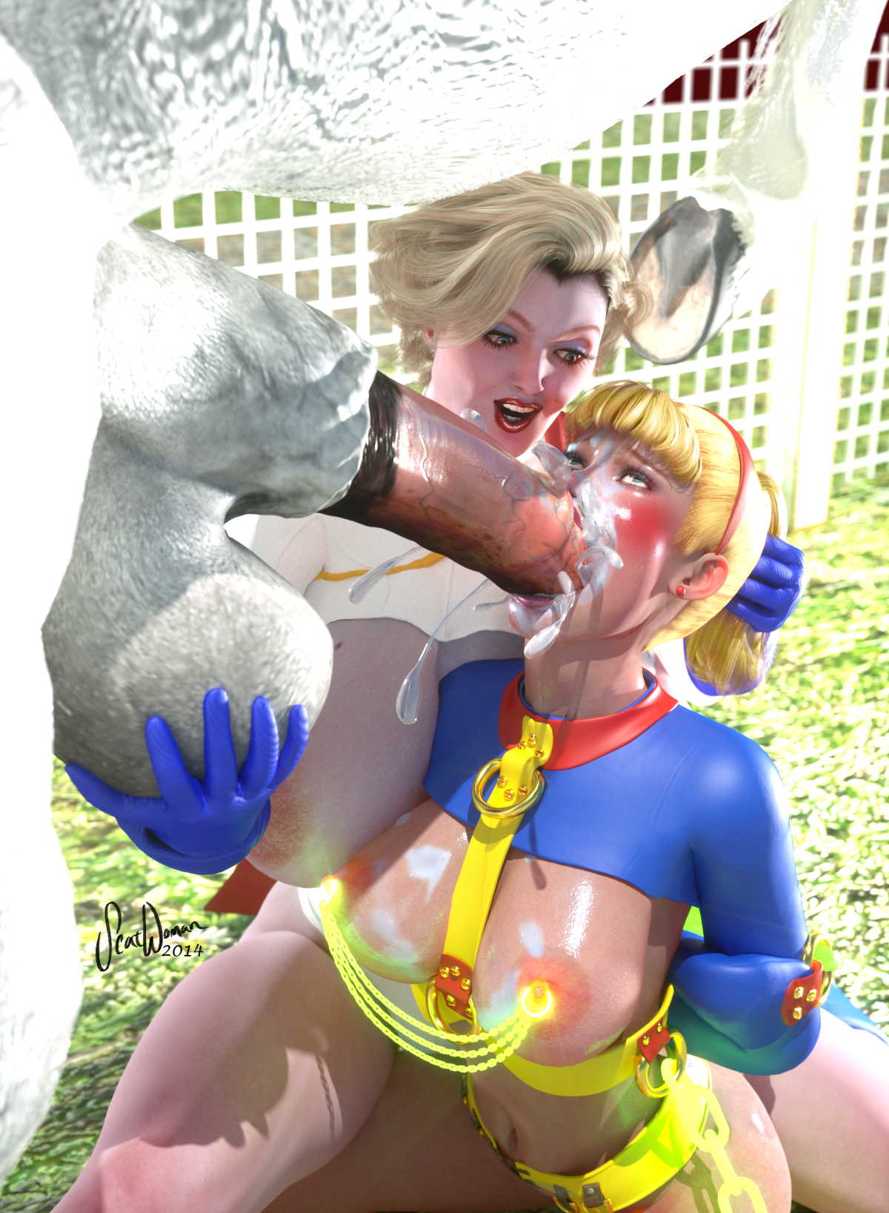

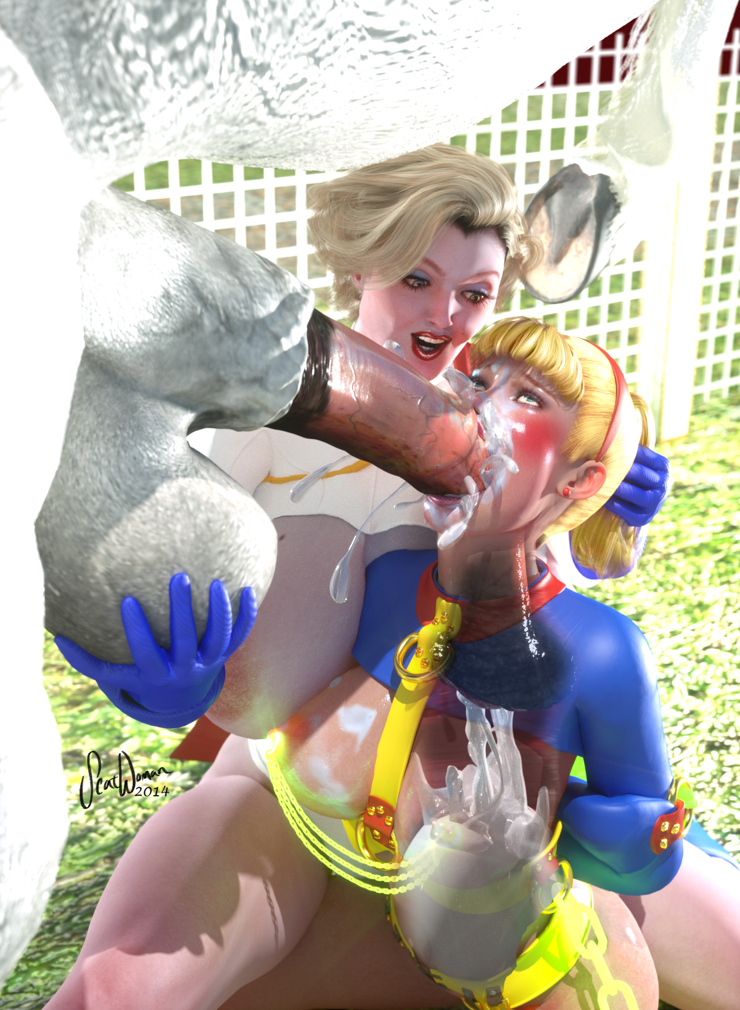

.....

When Supergirl came to, she was being dragged across the dirt floor of the Kent family barn by her ponytail.

"You have been a VERY bad girl!" Power Girl was berating her as she dragged her deeper into the barn, "a dirty, nasty, filthy little shit-eating animal-fucking slut! Clark will be SO disappointed in you, young lady!"

Power Girl stopped at one of the stalls and roughly threw Supergirl in. She unceremoniously landed in the hay and tumbled like a ragdoll, her face plopping down in a large, warm pile of fresh horse shit.

Power Girl saw this and laughed her ass off.

"Oh my GOD, that's so fucking perfect!" she could barely contain herself, "well, I guess that'll give you something to do until I get back!"

Supergirl moaned, but was too weak to move. She was so stuffed with animal jizz, piss and Power Girl's hefty shit that she felt like she weighed a ton.

"I'm going out for a while," Power Girl explained as she gathered some rope, "I'm going to keep your here for your own good so you don't get yourself into any more trouble! You can take that time to digest your meals and contemplate all the terrible, nasty things you've done today, you naughty bitch."

Power Girl tied the strong rope through one of the sturdy, steel tie rings bolted to the studs of the barn with an expert knot, then tied the other end of the rope to the gold ring on the back of Supergirl's collar. It gave her enough slack to move around in the stall, but not enough to exit it. It was a large stall for about 3 horses, including Comet, who Power Girl was leading back in.

"Now you be a good girl, Superslut, and take care of Comet and the other horses while I'm gone," Power Girl spoke to her in that patronizing, sing-songy voice one would use with a dog, "if they need relief... ANY kind of relief," Power Girl's face betrayed what her sick imagination was dreaming up, "YOU will handle it. Understand?"

Supergirl tried to lift her head out of the pile of dogshit, but Power Girl stepped on her head and pushed it in further. Hot, nasty horse shit was shoved up her nose and into her mouth.

"Yrss, I umdrstnmd!" Supergirl's obsequience was muffled by the pile of equine excrement.

"Good. You can start by cleaning up this stall, it's a MESS," Power Girl waved her hand to ward off the stench.

As she left and locked the stable door, she added:

"With your mouth, of course," and she smiled, laughed and strolled out of the barn, leaving Supergirl to her awful predicament.

"Oh!" Power Girl called as she was about to close the barn door, "and when I come back, I'll be bringing company! So clean yourself up as best you can, you filthy little whore!"

Supergirl moans as the doors shut and the barn darkened.

Then Comet took a huge a shit on her head, piling on top of the massive pile she was already face-down in and covering her head completely.

Supergirl moaned in humiliation and hoped Martha didn't come home and find her like this! She'd die of embarrassment.

What she didn't know was that it was Wonder Woman who was on her way to the Kent farm that very instant!

To Be Continued!

(side-story branches off here in “Power Girl Savaged By She-Hulk!” and then continues in next part)

-Scatwoman

