Supergirl’s Cumming of Age
Story and Art by Scatwoman@aol.com


Chapter 3: “Power Girl’s Piss-Drinking Ponygirl!”

Superman and Wonder Woman returned to the Fortress of Solitude battle-worn and weary from their epic battle with Doomsday. It had been a long day and Superman was eager to turn in and rest.

Superman looked around for Kara, but couldn't find her. He was incensed.

"I told Kara to stay here!" he grumbled, "who knows what kind of trouble she could get herself into out there on her own!"

"She's not a kid, Clark, she can take care of herself," Wonder Woman was looking around carefully. Something had happened here. She could sense it. Superman, like most men, wasn't paying attention to the details, picking up on the little hints here and there. A scrap of torn fabric. Cracks in the floor. The scent of sweat and... sex? She sniffed the air. There was definitely a strong scent of sex, and she hadn't been alone! A sly smile crept across Diana's face. There was more to that wholesome little minx than met the eye! But who had she been fucking?

Superman was in the hall, now, checking the guest quarters and calling out, "Kara! Kara are you here?"

Wonder Woman noticed a small pool of whitish/yellow liquid, congealing in the coolness of the Fortress. She dipped a finger in it and put it in her mouth tasting it. It had a sweet, but also acidic taste. Like a mix of urine (a flavor she knew well from her games on Paradise Island) and... semen? That was not a flavor she was intimately familiar with, but there was something familiar about this particular taste. Yes, she's tasted this semen before... it must belong to... of course!

As the realization of what likely transpired here - and with who - dawned on Diana, she cracked a wide grin and chuckled to herself.

"Well... good for you, girl!" Diana muttered, "and you, too, Krypto you naughty boy!"

"UGH!!! GROSS!" Superman's cry came from Power Girl's quarters.

Wonder Woman, intrigued, came running to see what Superman had discovered. When she arrived in Power Girl's room, it was empty.

Moments before Wonder Woman and Superman returned to the Fortress of Solitude, Supergirl managed to slip out using what little power her kryptonite bonds had not sapped from her.

But the room STUNK like a sewer!

"URKH!" Superman gagged and stumbled out of the room, "Power Girl is such a slob! What does she DO in there?!"

The room WAS a mess. Various outfits, books, electronics and knick-knacks were strewn about the room. The bed was a mess. Wonder Woman visually surveyed the room carefully, unfazed by the stench. She saw some porn stashed here and there and more than a couple sex toys. And there was a large lead chest in the corner that piqued Wonder Woman's curiosity. What kinds of kinky shit was she keeping in there that she didn't want other Super-people to see with their X-Ray vision?

"Diana! How can you STAND that God-awful STENCH?!" Superman cried out, stepping back towards the room, then retching and backing away again, "ohhh, God... I think I'm going to puke..."

Wonder Woman shook her head and rolled her eyes with disdain. Clark may be the mightiest man on Earth, but sometimes he was such a fucking wimp. Besides, shit was a smell Wonder Woman WAS intimately familiar with. When you live on an island of Amazons cut off from the world and all men for thousands of years... well, people always need new things to keep things sexually arousing and... things tend to get VERY kinky after a couple thousand years. Diana knew the rest of the world would never understand, Clark least of all. So she kept that side of her Amazonian heritage to herself. But the stench in this room, along with a glimpse of Supergirl's discarded costume buried in the corner gave Diana the feeling that perhaps Power Girl shared some of the same kinks... and had introduced Supergirl to them!

Wonder Woman knelt on the ground and sniffed. There was something else. Someone had cum. Power Girl or Supergirl, she couldn't tell. But whoever it was had cum HARD.

"Oh my GOD! Are you SNIFFING?!" Superman couldn't believe his eyes as he saw Wonder Woman on all fours, head to the ground and taking sharp, deep breaths, "do you have NO sense of small, Diana?!"

Wonder Woman stood and walked out of Power Girl's room. Superman shut and locked the door as soon as she came out, covering his mouth with his cape and holding his breath. He gasped a sigh of relief as he walked away hurriedly.

"I've GOT to remind Karen to cut back on the beans!" Superman shook his head as he walked off.

"Clark, Kara's fine, don't worry," Wonder Woman put her hand on his shoulder reassuringly.

"You don't know that. She could be anywhere, getting into who knows what kind of trouble," Superman sat heavily on his bed, exhausted - physically and mentally.

"Look, you're beat. Let me go find her-" Wonder Woman began.

"No, I should-" Superman interrupted, about to stand back up, but Wonder Woman held him down with her hand on his shoulder.

"No," she said firmly, "if she's run away, you're the last person she's going to want to talk to. Let me find her. I can talk to her. Woman to woman."

Superman didn't protest. He knew Diana was right. "She's just a girl, Diana."

Wonder Woman let the patronizing remark slide. Sure, Supergirl was still a young teen, but she was more woman than girl now... especially after her experiences today!

"You rest," she offered, "I'll look for her on my way back to Themyscira. I'll let you know if I find her. But I might want to take her to the Amazons for a while, just to give her some... distance. And we could teach her some discipline. We're pretty good at that. It'd be good for her to spend some time with other strong women... don't you agree?"

Superman didn't reply. Wonder Woman looked back over her shoulder and saw he'd sunk back into the bed and had already fallen asleep.

Men. No stamina.

Wonder Woman shook her head, secured her golden lasso and headed out, eager to see what new erotic adventure Supergirl was getting into now.

.....

Nearly 3,000 miles to the South, Supergirl crash-landed in the pasture of the Kent Family Farm. She had taken on a secret identity here for a while after arriving on Earth. Clark had wanted her to assimilate with humans, to understand Earth like he did. Clark's mom had been really nice, and very understanding.

Kara had no idea how she was going to explain her predicament to Martha - bound in kinky bondage gear with kryptonite chains... she'd probably just blame it on Lex or whatever supervillain came to mind. Martha would understand. Martha would help her. She would clean her up and make her feel like a normal girl again.

It took all of Kara's strength to crawl her way up to the front door of the Kent house. It was hot and dry today and she was dying for a drink. The overwhelming nasty foulness of Power Girl's shit still coated her tongue and was stuck in her teeth and the crevices of her mouth. She'd give anything for a tall glass of water to rinse it all out with. But first she had to drag herself to the Kent house's porch.

She had flown all the way from the Arctic with what little energy the kryptonite chains (not to mention the foot of kryptonite dildo shoved up her ass!) had not sapped from her, and it had been very slow and unsteady going. Even at that slow speed, it had taken everything she had. She collapsed to her knees as she reached the front door. As she dropped her ass to the porch, the dildo slammed deeper into her colon, making her wince. Her arms still securely bound behind her back the whole flight here, it was all she could do to try to shit it out, but it was in there too deep and she gave up somewhere over Canada.

Kara had no free hands to knock, so she leaned forward, stretched her neck as far as she could and stuck out her tongue to ring the doorbell. She heard the bell chime inside the house and let herself sink back and relax. Her ordeal would be over soon now.

But nobody came to the door. Then it occurred to Supergirl - what if she wasn't home? Kara tried using her x-ray vision to check, but she could barely see past the first layer of paint on the door. She was just too drained. Where could Mrs. Kent be? Visiting her family? Sometimes she does that and is gone for days at a time. What was Kara going to do? She didn't have the energy to go anywhere else. Maybe she could hide in the loft in the barn until she returned? Would she last that long, or would the kryptonite sap her of her remaining energy by then? What if Clark came home first and found her like this?!!

Suddenly, Kara's heart jumped as she heard the doorknob turn! She looked up and smiled in relief as the door swung open and she was greeted by the kind face of...

Power Girl?!!

Kara groaned and fainted right there on the porch.

.....

Water splashed on Kara's face, into her nose and mouth. She began to choke on it and it immediately startled her awake.

Her eyes had difficulty adjusting to the sunlight; it was right in her eyes. But she could make out Power Girl standing over her, holding some kind of hose and spraying Kara in the face to wake her up.

But the water wasn't cold - it wasn't the temperature that shocked her out of her stupor. It was actually warm. Very warm. In fact, it was almost hot. And it stung her eyes... it was salty, and... acrid.

Kara heard a familiar whinny and recognized it as belonging to her Superhorse, Comet. Then as her eyes finally adjusted to the brightness of the mid-afternoon sun, she became aware of her surroundings. They were near the barn, by the stables. And then Supergirl realized with horror that it wasn't a hose in Power Girl's hands after all. It was a cock. A giant horse-cock. Comet's cock!

And it was spraying her face with hot horse piss!

"BLAGH!!" Supergirl coughed and gagged, trying to pull away, but Power Girl grabbed her by her ponytail and held her in place so that she'd get the full blast in her face.

"Don't you pull away and act like you don't want it, Superbitch!" Power Girl taunted her as she squeezed Comet's shaft, temporarily halting the torrent, "open that little toilet mouth of yours nice and wide for good ol' Comet, here!"

Supergirl looked up at the busty Kryptonian woman, intimidated and cowed. She tried to focus on her face through piss-drenched eyes. She was looking for any hint of mercy, of any sign the bigger woman might possibly relent.

Kara found none.

"OPEN, WHORE!!!!" Power Girl screamed in her face, barely half an inch away. Supergirl felt Karen's spittle dapple her face.

Quaking in fear, Supergirl reluctantly obeyed, opening her mouth slightly.

"Bitch, don't play games," Power Girl admonished her, "WIDER."

Supergirl did as commanded and opened about twice as wide.

"WIDER, CUNT!!!" Power Girl yelled in her face again.

Kara flinched and this time opened as wide as she could. Immediately Power Girl eased her grip on Comet's throbbing horsecock and a powerful gush of hot, nasty horsepiss blasted right into her mouth, filling it rapidly.
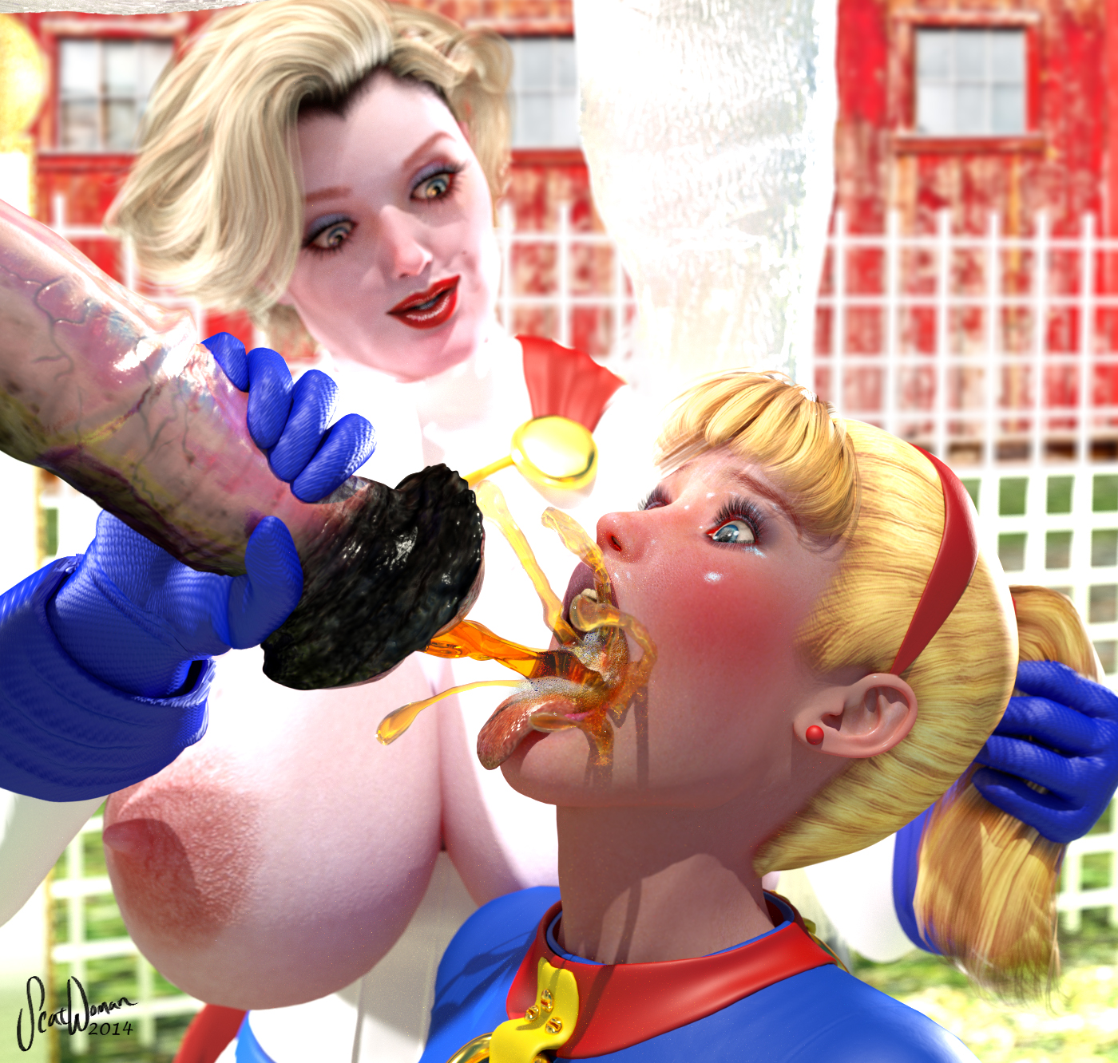
"Mmm, yummy, isn't it, bitch?" Power Girl chuckled, "see how nice I am? Giving you a nice, refreshing drink to wash down all that nasty shit you gorged yourself off earlier like the greedy little toilet slut you are?"

Supergirl's mouth was soon filled to the brim and Power Girl squeezed again to stop the flow. She looked down into Supergirl's open mouth to see all the horse piss pooled inside.

"Wow, I can see all the way to the back of your throat!" Power Girl admired the view, well-lit by the full afternoon sun, "That's a fuckin' TON of horse piss!"

Power Girl took a sniff then scrunched up her nose, repulsed, "UGH! That stinks! How can you drink that stuff, you filthy toilet-mouth?!"

Power Girl laughed and then turned very serious, locking eyes with the terrified teen.

"DRINK." she commanded, "After all, you ARE just a fucking worthless toilet slut!"

Jerking slightly from her silent, internal sobbing, Supergirl stared right into Power Girl's pitiless light blue eyes and gulped loudly, taking a good third of the horse piss down her throat. She felt its warmth wash over her insides and fill her belly, joining the other filthy contents from earlier in the day.

"Good. Keep your mouth open while you swallow the rest," Power Girl instructed her, "I want to see it..."

Twice more Supergirl had to swallow in order to get it all down, and Power Girl leered with lurid fascination as she watched it all disappear down the teen's gulping gullet.

Power Girl had that look on her face that Supergirl now dreaded. She was horny as Hell now and there was no telling what she would do next. And no stopping her once she decided to do it.

"What's that?" Power Girl asked without prompting.

"Wha..?" Supergirl was confused.

"You want more?" Power Girl acted surprised.

"I... I don't-" Supergirl tried to respond, but it was moot.

"Well, if you insist, you thirsty piss-whore!" Power Girl acted as if she was doing Kara a favor and unleashed another scalding torrent of equine urine right into Supergirl's mouth.

It caught Kara by surprise and made her cough, but soon enough her mouth was filled to the brim again.

This time all Power Girl needed to do was look at Supergirl and she gulped down the rancid horse whiz, leaving her mouth open wide for Power Girl to admire her piss-guzzling skills.

"Good, very good!" Power Girl commended Supergirl. Despite herself, her tormentor's praise filled Supergirl with some sick, masochistic pride.

"Th-thank you..." Kara managed to sputter, still choking on piss a bit.

Power Girl's face lit up at this. She knew now that the blonde teen was HERS, completely. She would do WHATEVER Karen wanted and do it gratefully.

"And...?" Power Girl prompted the subjugated teen.

Supergirl looked at the beautiful, dominant woman's expectant gaze questioningly. Then she looked at the horse cock, still aimed directly at her mouth. She knew what was expected of her. She might as well accept it, she figured. This was her life, now. Power Girl had made her this perverse thing she had become. If this was to be her life, now, she would need to embrace. It.

"Please," Supergirl looked directly into Karen Starr's eyes with such earnest surrender and submission that it made the busty woman's heart flutter, "Please, Mistress... can I have some more horse piss?"

Power Girl smiled wider than Supergirl had ever seen and immediately the teen girl's mouth was flooded with yet another unrelenting torrent of hot, pungent horse piss from her pet horse's massive dick. Its wide flanged head flared as it unleashed its golden geyser right into her mouth.

Supergirl let go of all pretense of resistance and began to gulp down the piss continuously. She tried to swallow as fast as it was coming, to prevent it from spilling over and down her bared breasts.

Power Girl saw this and flushed with sexual arousal at the girl's incentive.

"Oh, yeah, guzzle down that hot horse piss, you FUCKING SLUT!" Power Girl hissed as she ogled the action lasciviously, "Drink it ALL! Don't you spill a fucking DROP, you goddamn toilet-mouth WHORE!"

Supergirl did as commanded, but she began to fall behind. Her eyes widened in panic as she realized Comet's stream hadn't been at FULL blast before - Power Girl had been holding him back! How much damned piss did this horse have, anyway? Somewhere in the back of Supergirl's mind, the Earth idiom of having "to piss like a racehorse" came to mind and now she knew exactly what that meant. Her stomach was already full from Krypto's large dog-jizz deposit this morning and Power Girl's massive, epic shit-log just a few hours ago... now all that was sloshing around in her bloated belly in a growing pool of steaming stallion piss. She wasn't sure she could swallow another drop of Comet's urine... but what would happen to her if she stopped and it spilled? What horrible torment would Power Girl concoct next to punish her for her weakness?

It turns out, Supergirl needn't have worried. For Power Girl jammed Supergirl's head forward forcefully, shoving the still-spraying wide head of Comet's horsecock right into the teen's gaping mouth, bulging her cheeks out obscenely! The flanged glans of the animal's prodigious dick was so wide it filled her entire mouth and propped her jaw open uncomfortably. Not only that, the fit was so air-tight there was no place else for the piss to go but straight down the poor girl's throat! Full or not, she was going to drink every last drop of the Superhorse's epic bladderful of salty, potent piss!

"Oh FUCK yeah!" Power Girl rasped huskily, "now you're a REAL human toilet, Superbitch! Take all that hot horse piss right into your nasty little tummy!"

Power Girl had now released her right hand from Comet's cock, keeping Supergirl in place with her left hand squeezing the blonde's ponytail tightly. She looked down at Supergirl's bulging belly and grinned. Running her hand over it she tisked disapprovingly, "Hmmm, somebody's been a bad little girl!" Power Girl chided the guzzling girl mockingly, "Somebody's been overindulging in sweets and chocolates haven't they?" She snickered at this, "And I KNOW how much you love a big hunk of 'chocolate'!"

Supergirl moaned at the reminder of her earlier ordeal between Power Girl's muscular ass cheeks.

"A nice big hunk of fudge... a big batch of brownies... big-ass tootsie rolls," Power Girl went on, "You've got quite the appetite for fattening foods, don't you?"

Supergirl could only look into Power Girl's sadistic gaze as her stomach grumbled at the thought, even as it rapidly filled with hot horse piss, making the most disgusting slush in her guts. First Krypto's powerful, hot injection of dog superjizz, then Power Girl's massive log of shit... and now her own pet horse Comet's scalding hot piss! Has anyone in the universe ever had a more potent, more revolting mixture of bodily fluids and wastes bloating their belly like Kara had at that moment? She felt like the most debased, degraded girl in the whole world...

But, finally, mercifully, the torrent subsided! The last few spurts of retched piss sprayed across her tongue and slid down Supergirl's throat until she had guzzled down every last drop of it, as Power Girl had demanded of her. At last it was over!

Or so she thought...

To Be Continued!

-Scatwoman

