Supergirl’s Cumming of Age
Story and Art by Scatwoman@aol.com
Chapter 1: “Throat-Knotted by Krypto!”

Supergirl was angry and petulant at having been ordered to stay behind at the Fortress of Solitude while Wonder Woman and Superman went off to fight Doomsday (again!)...

She moped and plodded around the Fortress, sighing heavily and generally being every bit the teenage brat she was.

She considered just flying off and not coming back. That would show them! She wanted to rebel against them, show them she could handle herself. But she was also afraid to make them mad. They really intimidated her... especially Wonder Woman and that lasso of hers! Many times Wonder Woman has offered to take Kara away to Themyscira for "proper training", but Superman always politely declined. Kara didn't like the sparkle Diana would get in her eyes every time she proposed the idea...

Lost deep in her sullen, self-indulgent self-pity, Supergirl didn't hear Krypto enter. Happy to see her, he leapt at her with super-speed, tackling her to the floor with super-strength and licking her face with super-dog-spittle!

Supergirl was caught by surprise, but couldn't help but be cheered up by the always happy, always hyper-energetic superdog. If she had one friend on this world who loved her unconditionally, it was Krypto. He always cheered her up.

As Krypto's licking got more intense, she tried to get up, but he held her down firmly. He was a very large dog and, being a super-dog, could overpower her just as a comparable-sized dog could easily overpower a human waif of her size.

"Krypto! Stop it!" she giggled. But he kept licking. His front paws were mauling he breasts and she started to feel very trapped.

"Okay, Krypto, I said enough!" she knew Krypto was smart, not just a normal dog with super-powers. She was pretty sure he could understand her.

"Enough!" she yelled and tried to push him off. It almost work, but then Krypto shoved her back down on the ground HARD, cracking the floor a bit and shredding her top! Her pert, young breasts were now totally exposed, her pink nipples stiffening in the cold of the Fortress.

"Hey! My costume!" she wailed and she struggled to get free. "Ow!" she cried out as she felt Krypto's claws scratch at her sides, trying to hold her down, "Krypto, you're hurting me!"

"WOOOF!!!!" came the super-loud reply, loud enough to rattle the entire Fortress. It was a deep, powerful, authoritative bark that paralyzed Kara with fear. Her eyes went wide, looking into the now menacing, growling face of her canine captor.

"G... good boy, Krypto," she squeaked weakly, trying to get on his good side and calm him down, "I'm your friend, remember?"

Supergirl wondered if he had been brainwashed or was being controlled by some evil mastermind... She figured it was Lex, up to his old tricks again. If only Superman and Wonder Woman were here to save her from whatever diabolical plot was being set in motion!

Supergirl then felt something down on her thigh. Something very warm and hard. she looked down to see Krypto's MASSIVE super-cock, throbbing, bright red and veiny, fully sticking out of its furry white sheath. Krypto was obviously VERY happy to see her!

"Whoa.." was all she could mutter. She'd never seen a penis before, much less a dog one. She had no idea that could get that big!!

Krypto slowly and deliberately turned around, keeping his large, heavy paws firmly on her, keeping her down with his weight. Not that she was even trying to get away, she was too transfixed and intimidated by the sight of his enormous dog dick - she was completely lost in the moment, forgetting her predicament.

It wasn't until Krypto stopped in a 69 position with the supine Supergirl - with his heavy, hot cock dangling right in front of her face - that Kara realized what was about to happen.

"Hey, Krypto, what are you-" she began. But Krypto reached down, bit into her crotch and tore off her super-panties, making her scream in shock and pain.

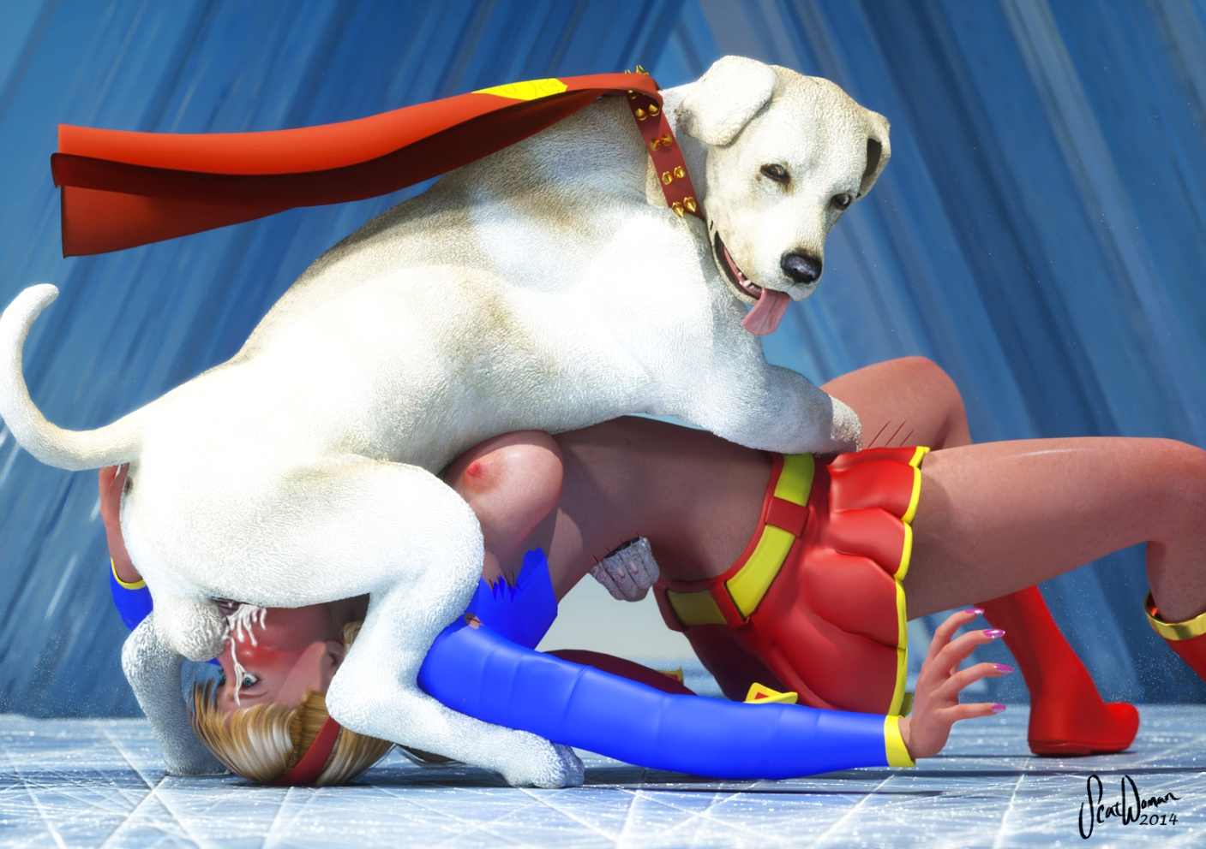

"AAAGG-GRRMMPHHH!!!" she cried out, only to be muffled by Krypto's fat, veiny dick as he took advantage of the opportunity to shove his throbbing hot cock into her throat as far as it would go with a single, powerful super-thrust!

Supergirl gagged on the enormous dick impaling her throat, bucking and thrashing. But Krypto slammed her down, scratching her legs and holding her down tight as he her struggle and get used to the feeling of accommodating his impressive girth and length.

...

Soon enough, she stopped struggling. Krypto knew that, like all of the Super-family, she could go for long stretches without oxygen. They could fly through space unprotected, after all! It was just the reflex action, an autonomous response that made her gag and panic. But now she had settled down and seemed to be accepting her situation, at least physically.

Now as his hock cock throbbed inside her throat, he grabbed hold of her tightly, with one paw around her waist and the other on her exposed cunt. She moaned at the feeling and he could feel her getting wet. He could smell her sex responding and he knew he had her.

Taking his back paws off of her pinned arms, he placed them on the ground so that he could get better leverage for fucking. And then he went straight to work on her pretty face. Deeply and relentlessly he slowly fucked her cute little mouth, stretching it to its limit when the fat part of his cock shoved its way back in.

Now she was really moaning and she was even gyrating her hips, perhaps even involuntarily. She seemed pretty lost in the experience, not very aware of anything but his cock plunging into her throat over and over.

Krypto slowly picked up the pace and before long he was pounding her saliva-slicked face with all the super-speed and super-strength he could muster! The ground shook beneath them from the force of his thrusts and her eyes rolled back in her head. She had completely surrendered to the super-powered canine mouth-rape now and her mouth was simply slack-jawed and gaping, there to be fucked and used however Krypto demanded.

After about 15 minutes of full-tempo face-fucking, Krypto finally felt his balls twitching and he plunged himself all the way in to the sheath - burying his full one-foot cock into her well-used throat. His sweaty, furry sack sat on her nose and he felt himself throbbing inside her... growing... knotting!

...

Supergirl had lost all conscious thought during the savage face-pounding she had endured but now that Krypto had finally stopped and planted himself fully down her used gullet, she began to come to a bit. She felt his hot breath on her cunt and his heavy, warm paw that she'd been rubbing her swollen vulva and clit against. She could feel she was close to orgasm, but she was so confused. How could she be getting turned on by this?! By sex with a dog! And not just sex, being orally raped by a dirty, filthy dog-dick?!

She was distracted from this train of thought, though, when she felt something happening in her mouth. His cock... is was getting... bigger?! Was that possible? It was as if it was being inflated. It got thicker, and much much wider... her cheeks ballooned out, obscenely stretching to accommodate his expansion. Then she remembered something from her mammal biology eduprogramming that she experienced on her long journey to Earth. When a dog is about to... to cum... their penises inflate at the base to keep them stuck inside their... their bitch. She couldn't believe it. Krypto was KNOTTING her! Knotting her throat!!! He was much too big to pull out now - trapped in her mouth by her jaw, teeth and lips. No, there would be no pulling out until he was done with her poor, defiled throat!

Suddenly she felt a throbbing wave course down the substantial length of Krypto's swollen dog dick. She felt it first in his balls as they contracted over her nose. Then she felt it at the narrow base of his dick where her lips were tightly wrapped around it. She felt it along the length of her extended tongue (forced out of her mouth by the sheer size of his dick). She felt the knot throb in her cheeks, stretching them even more. And she felt the pulsation run down the length of her throat until it climaxed at the twitching head of his doggy dick and suddenly she felt the powerful, boiling blast of scalding hot dog jizz fire down her throat and splash into her empty, grumbling belly.

She groaned at the incredible sensation and even more incredible degradation of it. And she came. Harder and more powerfully than she had every cum before (all previous times had been just fingering herself while thinking of handsome superhero studs she wished were her boyfriends... though she'd never pictured Krypto in the role!). She rocked and shook and screamed (as best she could while being fully impaled on super-dog-dick) and came with a force that caught her completely unprepared.

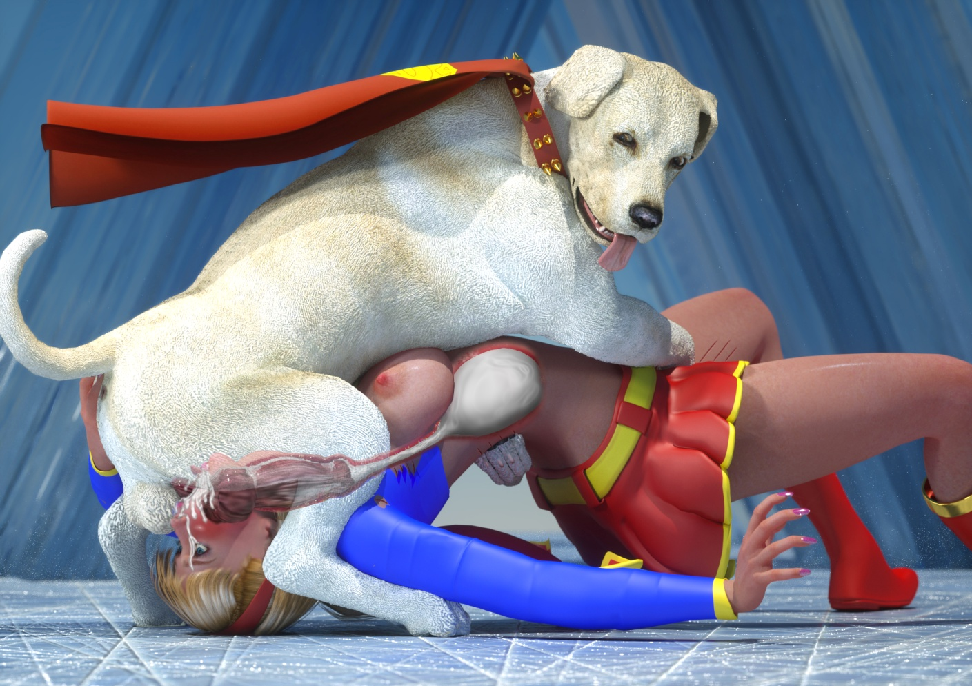

And as jet after steaming jet of super-potent dog jizz shot into her gut, she kept cumming. Each voluminous spurt would cause a new wave of ecstasy to ripple through her exhausted, lithe frame. Her knees shook, her vision blurred and she moaned deeply in total surrender to the intense, depraved multi-orgasmic experience.

Somewhere, back deep in the recesses of the still semi-aware, rational part of her mind, she remembered reading that sometimes a dog would knot for half an hour, constantly injecting their semen into their bitch... or in extreme cases, over an hour! She couldn't imagine how much super-spunk he could fill her with if he stayed in her that long! She hoped he would be done before Diana and Clark got back! She couldn't imagine how much trouble she would be in if they caught her like this!!

...

Being a super-dog, Krypto's knots lasted longer than any Earth dog's. It was a full 2 and a half hours before he had dropped his entire super-load into Kara's now-bloated belly. When his knot did finally deflate and he pulled himself out, Supergirl was so exhausted (both from the prolonged throat-knotting/jizz-pumping and her own multiple, powerful orgasms) that she simply fell limply to the ground, unable to move.

Krypto simply cleaned his dick and began to walk away, leaving her there to seed. But he stopped, turned around and came back over to her. Through blurry, heavily lidded eyes, she looked up at him with an expression equal parts submission, awe and gratitude.

Then he lifted his leg and pissed on her face, marking her as HIS.

She made no move to stop him or turn away. She simply let his hot piss run all over her face and into her mouth, filling the yearning void in her throat left by his hot, throbbing giant dock dick...

The Beginning!

-Scatwoman

