Cobra Strike

Catherine watched her target leave the office building and step into his chauffer driven car and the 4 security men who surrounded him every step of the way, she sipped her cappuccino from the cup which she held in her leather gloved hand, the light reflecting from her glasses as she watched the car pull away it would have been a simple matter to have planted a bomb under the car or even to have gunned them all down as they had walked from the office door to the car but that wasn’t Catherine’s style.
Catherine’s code name within the organisation was Red Cobra and that was due to the fact that despite her young age she was quick, deadly and she always succeeded in whatever task she was given, she finished her coffee having seen all that she needed to and walked to take the bus home to her flat which she shared with her mother.
At home Catherine mentally walked through the steps she would need to take in order to complete the job and she informed her mother that the following night she would be staying over with a friend, before she went to bed she sent a two word email to an email address ‘ Cobra Strike’.
The next day as Catherine worked at her normal job as a receptionist her mind kept wandering towards the end of the day when she would become the Red Cobra and do what she most enjoyed doing, finally the end of the day arrived and she waved goodbye to her colleagues and instead of taking the bus home she jumped on the tube in the opposite direction to her secret flat where she kept all the tools of her trade.
Arriving at the flat Catherine as always checked around before entering and then silencing the various alarms and traps that protected it, she smiled to herself at the surprise any wannabe burglar would get if they tried to break in, all the windows and doors were reinforced and alarmed and additionally put the wrong code into the panel and hidden explosives would destroy the block of flats.
Opening the door Catherine quickly tapped in the code and authenticated it with a retinal scan and then closing the door made her way into the front room she looked around and then moved into the bedroom where she removed all of her work clothes and walked into the en-suite bathroom and stepped into the shower where as part of her ritual she showered alternating the powerful spray between boiling hot and icy cold water.
Leaving the shower she wrapped herself in one of the towels and went and sat down in front of her dressing table and started to apply her makeup, she always took special care to make sure it was perfect as it would be the last thing her victims would see once she was satisfied she moved over to the fitted wardrobes and opened one and selected her outfit for the evening.
She pulled out a skin tight silver grey leather cat suit and put it on as always it took some time and Catherine took time to smooth out any wrinkles, then she put on a silver grey chest leather protector which also was form fitting and on the front was a motif of a cobra in red depicting her code name, Catherine then grabbed a pair of over the knee silver grey leather boots which had 5” stiletto heels and slipped her feet into them and slowly zipped them up ensuring a nice tight fit.
Catherine walked over to a drawer and pulled out a wide silver grey leather belt with a buckle with the Red Cobra motif on it which had a holster on the right side and a pouch on the left hand side and put it on and adjusting it so it fitted comfortably, next she reached back into the drawer and pulled out a pair of Silver Grey leather gloves which were extremely supple and slowly pulled them on over the sleeves of the cat suit and smoothed out the arms so that they reached to just below the elbow again on the back of the gloves was the motif of the Red Cobra.
As always when she got changed Catherine started to feel more powerful and evil and she knew that now she was the Red Cobra nothing or no one could stop her, due to nature of the job tonight she wouldn’t have to wear her red Cobra mask and she looked forward to seeing the looks on her victims faces as they realised that it was a 19 year old woman who was going to kill them.
Catherine checked her attire in the full length mirror and smiled at the striking figure looking back at her with her black hair flowing over her cat suit and her scarlet lipstick standing out she picked up her 9mm browning hi power pistol with its 14 shot magazine and held it up in a pose she noticed her glasses and thought once again about whether or not she should invest in some contact lenses.
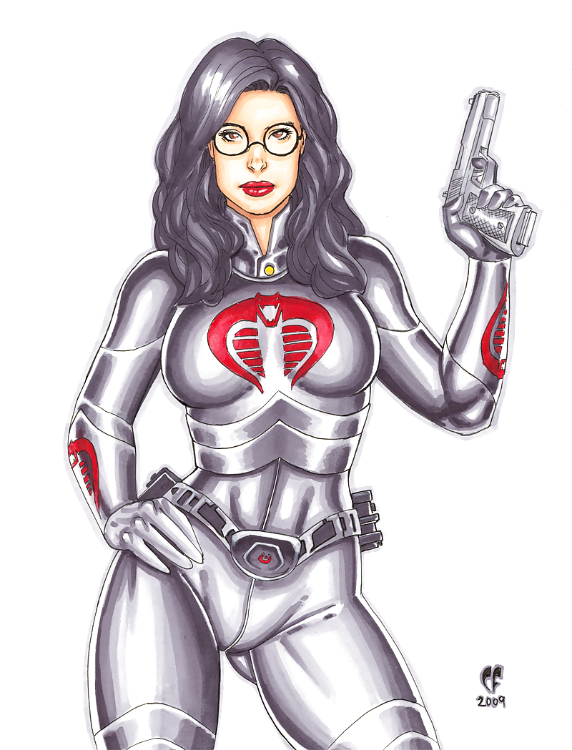

Nodding Catherine completed her preparations she put a long serrated edge hunting knife into the sheath that was on her right boot and clipped it into place and then into the pouch put several other items including a set of skeleton keys and an alarm box decoder, finally she reached over to the back of the cupboard and pulled out a full size Katana Sword which she strapped onto her back with the handle over her left shoulder.
Looking at the LCD watch which was built into her left glove she noticed it was time for her to leave and she went through to the kitchen and at the back opened a window and climbed out onto a fire escape, she pulled out a set of keys as she closed the window and pressed a button and all the alarm systems reactivated, with her base now secure Catherine made her way down the fire escape her metal heels echoing on the stairs.
Just around the corner in a secluded underground car park was a black and red Honda Goldwing which had been modified and tuned so that it was the fastest thing on the road, opening a pannier Catherine pulled out a black full face helmet like the rest of her outfit it had a motif of a Red Cobra on it with the helmet on Catherine entered the code which started the bike up and she expertly steered it onto the streets of London and started making her way towards her target.
She weaved through the back streets of south London avoiding main thoroughfares until she hit Streatham when she cut along the South circular road to the A3 and made her way towards the Hampshire Countryside within the hour she had parked up in a layby on a deserted country road and removing her helmet and shaking out her black hair reached in for a pair of night vision glasses and trained them on the country house which stood 200 yards off the road.
The layout was just as she expected from the plans she had been sent and she scanned the grounds of the house she saw the 2 guard dogs which were let out at dusk and the guard walking around that she’d have to neutralise first but she had a plan for that, there appeared to be no other movement around so she got on to the bike and rode down towards the gatehouse.
As Catherine turned into the narrow road which led up to the gatehouse she switched the engine off and coasted down to the gate stopping just outside of the limit of where the automatic lights which were situated on the side of the gates would switch on, she dismounted off the bike and reaching into the pannier pulled out a sealed freezer bag which had two large slabs of meat inside them and put it on the seat and then moved through the undergrowth towards the guardhouse.
Reaching into the pouch she pulled out the alarm decoder and it quickly overrode the gate entry mechanism and slid open just enough to allow her to slip through, Catherine moved towards the area that she saw the guard approaching and kept an eye open for the dogs, she spotted one then the other dog and quickly unsealed the freezer bag and threw one piece of meat right at the leading dog which hit it right on the nose and dropped to the floor.
It sniffed the meat and then quickly gobbled it down Catherine smiled and threw the second piece of meat just in front of the second dog which pounced on it and just as quickly it gulped it down, looking at her watch Catherine calculated that the sedative should take effect within a minute or two and both dogs would be comatose for at least two hours after all Catherine hated to see animals suffer.
Both dogs were on their sides as the roving guard noticed and rushed over Catherine had hidden herself in the shadows and as he knelt down she crept up behind him and with a garrotte she had extracted from the pouch looped it over his head and around his neck and with a knee in his back she pulled, he tried to struggle and pull the wire away from his throat but Catherine had too firm a grip on the garrotte and pulling back with all her weight she soon had the guard struggling to breathe and she pulled tighter before finally rupturing his windpipe.
Catherine took a deep breath and exhaled the close up personal kills were always her favourite ones and always excited her, she reached down and taking his slumped head in her leather gloved hands twisted violently and she was rewarded with an audible ‘crack’ as his neck snapped, her instructors had drilled into her about making sure of the kill, she wiped her hands against each other and made her way towards the main house.
When she had been making her plans Catherine had decided to enter by the old servants entrance as this would be the easiest access point and enable her to deal with any one in that part of the house first, using the skeleton keys it was less than a minute before she gained entry and she surprised a young maid who was just loading up the dishwasher.
Without a thought Catherine’s leg shot out and her 5” metal stiletto heel hit the young woman in the side of the head which caused her to stagger and as Catherine regained her balance her right hand reached down and pulled out the hunting knife and with her left hand exposed the young woman’s neck by pulling back on her ponytail and she slashed across the throat a leather gloved hand across the mouth quickly stifled any scream as the blood pumped out of her throat and Catherine quickly and efficiently slid the knife in between the ribs into her heart and then let her go.
The young woman was dead before she hit the floor and Catherine coolly wiped the bloody blade on the dead woman’s dress before walking over to the kitchen door and opening it to check whether or not anyone had heard anything, there was no one there so she walked across her stiletto heeled boots clicking on the stone floor to the other door which led to the dining room.
Opening the door slightly Catherine noticed that the room was empty and she smiled as she now knew where the occupants were likely to be and she knew exactly where the guards would be stationed and she decided to deal with the guards first as this would give her more time to deal with her main target, she made her way out of the dining room and into the main hall she slipped across and over to a small corridor which led to the rest room where the remaining two guards would be stationed.
A gleam of light from underneath a door gave Catherine the location of the rest room and the sound of the television would mask any noise, Catherine pulled out her chrome plated Browning Hi-power Pistol and pulled the slide back chambering a round and she raised her leg and kicked the door right by the lock.
The door wasn’t that sturdy and burst open with one kick and Catherine followed through the door and moved to one side she spotted one guard getting up from a comfy chair and scrabbling for his gun which was in a shoulder holster and she calmly shot him twice once in stomach and the second in the head, she spun towards her left to see the second guard drop the cups he was carrying in order to reach for his weapon and Catherine just smiled and shot him in his right elbow and then blowing him a kiss with her left hand shot him in the eye.
Moving through to a small control room she deactivated the alarm system and made her way back into the small corridor, she retraced her steps to the main hall and went to find her target and his wife who were now the only people apart from herself left alive in the house and if her information was correct she would know exactly where to find them.
She walked up the steps and holstered her pistol and reaching over her left shoulder and pulled the Katana out of its scabbard Catherine loved this particular weapon and the fact that it was just like an extension of her arm, she stood at the end of a long corridor and looked down at a selection of doors then she heard some noise from a door halfway down the corridor she moved noiselessly down the corridor due to the plush carpet laid down and opened the door slightly she saw an older woman dressed in an old fashioned evening dress with opera length gloves who was talking to someone unseen.
The woman smiled as she glanced at the door and Catherine realised that she had been spotted and she opened the door and walked in holding the sword two handed in front of her, the woman’s smile broadened as she entered and Catherine saw the other occupant who was her target he looked at Catherine and said ‘Who the blazes are you’, Catherine just smiled and said ‘Your Executioner’, he looked at his wife and said ‘Audrey call the guards and then the police’.
His wife arched an eyebrow and lit a cigarette and Catherine smiled and said ‘You can call all you want but they are all having a long permanent sleep’ as she said that he made a rush at her which is what Catherine was expecting and hoping for and she swayed out of the way and then kicked him with her foot as he went past, she followed up with a kick with her stiletto heel into his scrotum which caused to scream in pain.
His wife just sat smoking her cigarette and applauded and said ‘excellently done my dear, King Cobra was right when he said he had put an expert in charge of my husband’s assassination’, Catherine now realised how she had received such expert intelligence, her husband was now looking at his wife in horror as he realised what was occurring and he just uttered ‘why’ in a shaky voice.
She smiled and looked at her husband and said ‘Power my dear power, with you gone l will control your banking empire and the serpent organisation which this delightful young lady is a member of have made me a very attractive offer about laundering their money amongst other things, besides l want to see you suffer as well’ she laughed as she finished and then turning to Catherine smiled and said ‘honey l would love to see how you torment and torture him before despatching him’.
Catherine smiled back and looking at her victim slashed with her katana and one of the sleeves of his jacket and the shirt underneath were cleanly sliced away, over the next few minutes with various passes of her sword Catherine soon had him naked apart from his shoes and socks and he was trying to cover his nakedness as Catherine prowled around planning her next move.
With a sudden slash Catherine inflicted a massive long cut across his torso from his left shoulder down to his hip whilst it in itself was non- lethal it was extremely painful, and Catherine then inflicted several more long cuts all of which brought cries of pain from him and Catherine was enjoying herself no end.
She circled around and without warning she swung her katana and his head toppled off as the katana sliced cleanly through his neck causing a spurt of blood to fly onto the carpet, his body flopped over lifeless and the look of surprise was evident on his decapitated face, Catherine looked across at his wife who had sat there watching with a slight smile on her face who then applauded and said ‘ My dear l am going to go to bed now and of course when l wake up in the morning l shall be suitably surprised and distressed l assume that you can see yourself out, so until we meet again’ she got up and walked towards the door just behind Catherine and as she passed Catherine stroked her cheek with a gloved hand murmuring ‘lovely’.
Catherine cleaned the katana up removing any blood as she had been taught and made her way back downstairs and let herself back out through the servants quarters door and quickly recovered her bike, as she started it up and rode through the night back to her base she thought back over the evenings events and was pleased with her performance and hopefully it wouldn’t be long before she was called upon again.

