Carmilla: The Web Series
Season 3, Episode 16: Regrets, I’ve had a few.
“The Live sex show seen around the World”
By Darth Kal-el
Notice: This is a minor change to the actual story and gives detail the show left to our imagination. In the show when Laura and Carmilla have sex on the desk they knock the camera and laptop off the desk but in my story the camera kept rolling and the whole show goes out over the web. So when the whole world gets to watch Laura and Carmilla have sex live.
Disclaimer: I don’t own Laura or Carmilla or Betty. They are property of Kinda TV on Youtube. I am just borrowing them and the screenshots. I am doing this just for fun. If you like the story, watch the show or you can write your own fanfiction and upload it here on ASSTR.ORG.
Inside the Library: Laura and Carmilla talking in front of the camera.
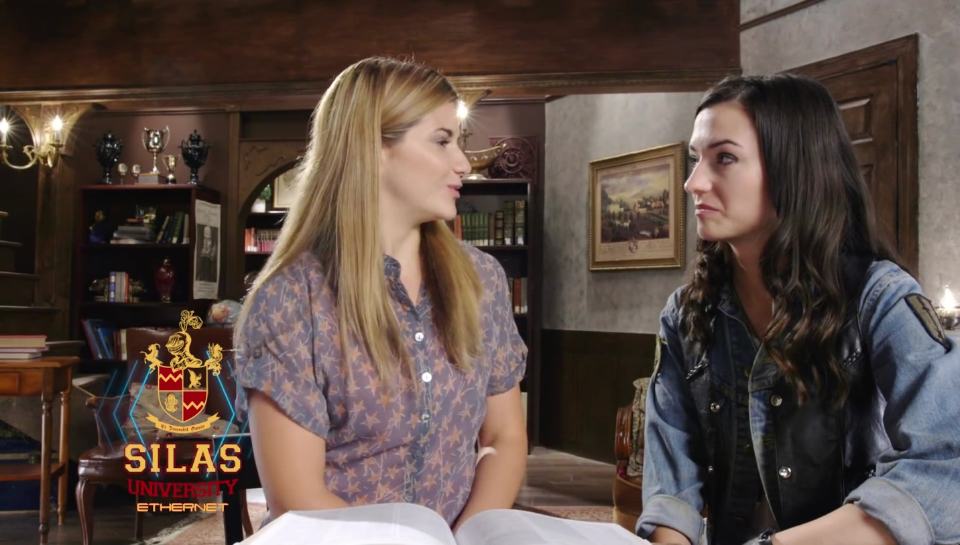
Carmilla: Look Laura Hollis chess Master.
Laura: Look at us making plans, no desperate kissing, no sexual undertones just platonic bodies.
With that Laura and Carmilla clutch at each other and start kissing desperately trying to make up for the lack of sex or love they have missed recently. Because even though neither would admit it, both ladies were still deeply in love with each other.
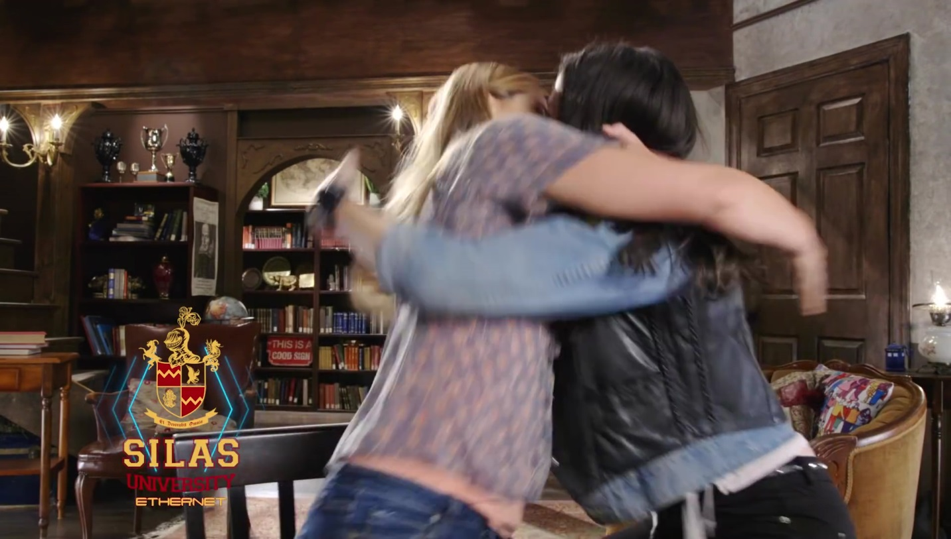
While still kissing the pair quickly shoved everything off the desk except for Laura’s Laptop. That they just pushed back, and the one thing neither lady realized is that the camera was still on and everyone watching including Betty could see what they were doing.
Laura pulled at Carm’s leather vest and yanked it off and threw it over to the stairs and at the same time Carm was pulling on the buttons on Laura’s purple shirt. After finally tossing off their tops the two lovers go back to kissing and Carmilla pulled away and starred at the hot blonde lady in her arms. She had never felt this way about anyone, she not only wanted to fuck the blonde but she also realized she was in love with this girl and if she survived, she wanted to spend the rest of her life with this blonde girl, but being the tough vampire she couldn’t admit it to Laura.
While starring at Laura, Carmilla hear’s Laura’s voice cutting through her thoughts. Laura’s words surprise her because Laura says.
Laura: Bite me Carmilla, mark me as yours and fuck me hard.
Carmilla can’t believe Laura wants her to bite her neck. She feels Laura grabbing her head and pulling her lips and fangs down to Laura’s neck where Carmilla begins to lick and suck on and feels the blood pumping and her vampire instincts kicked in as she bit down and Laura drawing blood and drinking from her lover. To Carmilla’s amazement Laura screamed out just as she began drinking from Laura’s neck, but this wasn’t a scream of pain it was a scream of pleasure.
Laura: Oh, God, Carm, yes drink from me. Make me yours.
IN ANOTHER DORM ROOM:
Betty is watching her friend kissing and making out with the vampire and she can’t believe her friend just ask the hot vampire to bite her neck and drink her blood. Betty hated to admit she was getting turned on and slowly put her hand down her pants and began to slowly message her clit while watching her friend have sex with the vampire.
BACK IN SILAS LIBRARY:
Laura pushes Carm off of her and begins to tear at the hot vampire’s leather pants. Laura wants that hot pussy and she wants the vampire to fuck her hard. Laura knew that Carmilla wore a leather harness under her pants and attached was a red plastic dildo. Laura needed Carmilla to use that dildo on her.
Once both Carmilla and Laura were naked they starred at each other. They both licked their lips, both were longing to taste the other’s body. Carmilla gently began kissing and nibbling on Laura’s breast, she would switch back and forth, first sucking on the right breast and then nibbling on the left breast. All of a sudden Laura pushed her off so she thought she did something wrong until Laura spoke.
Laura: I love the way you play and suck on my tits but I need you to take this red dildo and rape me hard.
Carmilla: Are you serious, you want me to rape you with my strap-on?
Laura: Yes I am serious I need to feel you inside me so ride me, bend me over, I don’t care; just take that plastic cock and fuck me as hard as you can make me scream so loud the whole world hears me.
Carmilla: If that is your desire my cupcake then I will rape you until you beg me to stop.
Carmilla bent down and began to lick and suck on Laura’s clit and her pussy; making it wet. When Laura started trying to push Carmilla off. Carm knew what Laura wanted but she just had to have a taste of Laura’s pussy first before she raped the girl.
Carmilla: Okay, Hollis, I’ll rape you but I just needed a taste of that sweet nectar of yours.
With that Carmilla pulled Laura Hollis to the edge of the desk and spread her legs wide enough so she could stand between them. She then grabbed her red dildo and aimed it the blonde’s pussy. Once the tip of her dildo was at the entrance to her lover’s vagina Carmilla shoved forward as hard as she could. She buried that dildo all the way in the girl, and then she pulled it almost all the way out and rammed it back in. And the vampire continued like this fucking and raping the mortal blonde as hard as she could, while the blonde screamed and moaned in pleasure begging for more and for the vampire to rape her harder.
HALF WAY AROUND THE WORLD IN BETTY’S ROOM:
Betty couldn’t stop watching as her friend was fucked by the vampire and screamed in pleasure as the vampire fucked her. Betty grabbed her vibrator and started pushing it in and out of her pussy which ached in need as she watched the lesbian lovers have sex.
BACK IN SILAS LIBRARY:
Laura let out a huge scream as she came all over the dildo buried in her pussy. Carmilla pulled out and began to stand up when Laura grabbed her wet dildo.
Laura: Get that strap-on off I want to taste that hot vampire pussy of yours NOW.
Carmilla was surprised by the need in Laura’s voice but she wasn’t done raping the blonde girl. She had long wanted to fuck the blonde’s hot ass and she was going to do just that.
Carmilla: NO! You asked me to rape you and I’m not done. I have wanted that hot ass of yours and today I’m going to use this dildo to rape your ass now stand up and bend over so I can fuck you up the ass.
Laura was in shock, but she was also turned on. She had asked Carmilla to rape her and she had dreamed of trying anal sex and now here was her vampire lover telling her she was going to rape her ass with her red dildo strap-on. With that Laura gently stood up and faced her lover, when her lover kissed her and then spun her around and bent her over the desk.
Carmilla: First I need some lube so I don’t hurt that hot asshole of yours.
Carmilla shoved her dildo into Laura’s wet pussy, coating the dildo in the blonde’s cum. Then the brunet pulled out and aimed the plastic cock at the blonde’s rosebud.
Carmilla: Okay now you asked to be raped and that is just what you’re going to get.
With that Carmilla rammed her strap-on into the blonde’s ass. She proceeded to fuck Laura’s ass as hard as she could. Even when Laura begged her to stop the Vampire kept going. An hour later she stopped and pulled out of Laura’s ass with a pop. Then Carmilla unhooked the strap-on harness and dropped it to the floor.
Carmilla: I have served you and gotten you off and now it’s your turn to satisfy my needs. So get that tongue and start eating my pussy now Cupcake.
With that Carmilla laid back in the overstuffed chair and spread her legs; showing off her pussy waiting for the blonde to dive in and start sucking on her pussy lips. Laura gently stood up and turned around and starred at the sight of her vampire lover with her pussy on display. Laura licked her lips, she had long wanted to taste that pussy and now she was going to eat that pussy until her vampire told her to stop.
Laura: Carmilla you fucked me until I screamed and begged you to stop and now you are mine. I’ll suck and finger your pussy until its soar and you beg me to stop. Your pussy is mine.
With that Laura knelt in front of the vampire and quickly dove head first into the brunet’s pussy. Where she began to lick and suck on the vampires pussy and clit. She also used her fingers making Carmilla cum several times. Eventually and hour later Carmilla pushed Laura off and begged her to stop because her pussy was too soar.
Laura: Now I’m going to wash up then we need to get back to figuring out how to convince The Dean’s sister to give us back the amulet.
Half an hour later back at the desk fully dressed Laura starts talking to the laptop when Betty calls.
Betty: Laura, next time you and your vampire lover want to get it on turn off the webcam. I mean that was the hottest sex show I’ve ever seen, and I did cum watching you two; specially when you dove between the vamp’s legs and started sucking her pussy. But seriously next time you want to have sex go somewhere else or atleast turn off the camera because everyone who watches you feed got to see you two have sex.
Laura sat stunned, she couldn’t believe that the whole world got to see her and Carmilla have sex but at the same time the thought of thousands of strangers and Betty watching them turned her on.
A little while later while talking to LaF and her dad and Carmilla about how to stop the Dean. Laura looks at Carmilla’s ass and slaps it. Carmilla is shock and looks at Laura when Laura grabs her by the ass and pulls her into a hot kiss and Laura says.
Laura: Leave the planning to dad and LaF, I want that hot ass but this time I don’t want anyone watching what I do to you.
Carmilla: What, are you talking about Cupcakes? And what do you mean watching us.
Laura: Oh, didn’t I tell you Betty called earlier and it turns out the webcam was on the whole time and the whole world got to watch us have sex live.
Carmilla was stunned, one that the whole world had watched them have sex and Laura was ok with it and now that Laura would grab her and openly talk about sex in front of her over protective father. Laura grabbed Carmilla and pulled her to the archive away from her dad and Laf so they could have sex.
Laura: Dad, Laf, if you hear any screams it’s just us. I am going to fuck Carmilla silly and I’m going to make her eat my pussy all night until her jaw is soar.
Laf and Mr. Hollis stare as the lovers leave and head to have sex.

