Alice in Wonderland:
Alice gives the Mad Hatter an Unbirthday present.
By Darth Kal-el
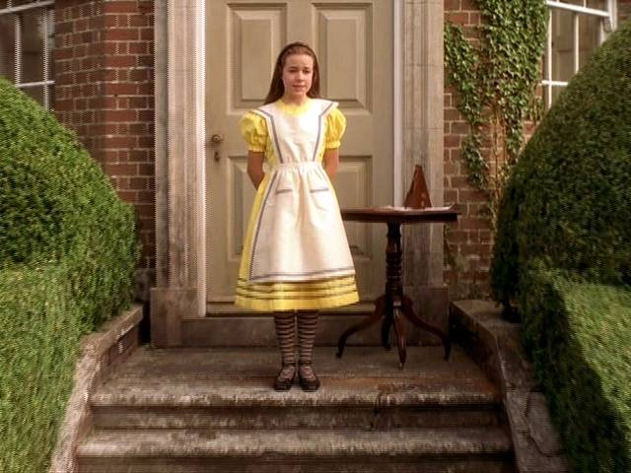
Opening Scene: At The table outside the Mad Hatter’s house.
The Mad Hatter starred at the 10-year-old-girl at the end of the table. She had just started developing tits, they were probably size A maybe B. He and the March hare would need to fuck this girl but the question was how. Then he realized the girl is gullible and would probably do anything he told her. Finishing up their tea, the Hatter said “Alice since it’s my unbirthday, do you have a present for me?” Alice didn’t have anything for the Hatter but she didn’t want to be rude so she replied “No I don’t have a present but can I do something to make up for it?” The Hatter smiled because this was just what he was hoping the young girl would say. “Well we can play a special game, first we’ll clean off the table and then you sit on the table.” Then in a hurry the three cleared off the table leaving only the tea pot with the door mouse inside it. The one thing about the table that made it different was that the Hatter had bought it from the Red Queen of Hearts and she used to use it as a torture were she shackled people to the table and tickled of beat them until she cut off their heads. So the shackles were still attached underneath the table cloth were Alice couldn’t see. The Hatter then said “Okay, Alice, sit on the table and lay back, then we will teach you a special game we play here in Wonderland.” Alice being only 10 was still innocent and didn’t see any reason to fear the man in the big hat. So the 10-year-old girl sat on the end of the table and laid down with her legs hanging over the edge of the table. While Alice was looking at the Hatter the March Hare grabbed the first shackle and that one went across the girl’s waist holding her down so she couldn’t get off the table. Alice felt the metal belt and wondered why she needed to wear it. “Mr. Hatter, why do I need this metal belt?” The Hatter starred at the naïve girl and loved this, she was now his captive and she still didn’t know that she was about to be raped. “Well, Alice the strap is to hold you still so you don’t fall off and get hurt, now please put your arms above your head.” Alice immediately obeyed putting her arms up and when she did the March Hare hooked her arms in the other shackles, securing the young girl to the table and making sure she can’t move. The Hatter starred at his prisoner, “Now, Alice, try to move your arms and try to get up off the table” The girl immediately tried to move her arms and found they wouldn’t move and when she tried to sit up she couldn’t. “Mr. Hatter I can’t move, can you please let me up?” Hearing that the Mad Hatter smiled an evil smile knowing what was about to happen and there was nothing the girl could do to stop him. Not only was he going to rape the girl but he was going to knock her up and force her to have his baby. “Well Alice that is part of the game, you aren’t supposed to move. I want you just as you are. Because the game we are going to play is called Rape.” Alice looked confused, she had never heard of a game called Rape, in her world rape was when a man forces a girl to have sex but this was a game so it wasn’t that. The Hatter immediately started undressing leaving on only his hat. He then took his scissors and cut the girl’s skirt off and cut her top and then began to rip the clothes off leaving the young girl naked. “Mr. Hatter why did you cut my clothes off, I’ve never been naked in front of anyone before.” The Hatter smiled, “I removed your clothes and mine because I am going to rape you and that means I am going to have sex with you. I am going to take my penis and fuck you.” Alice started crying, rape here was the same as in her world, this man was going to touch her privates and put his thing inside her. As she was crying, the Hatter took his cock and put the tip at the entrance of Alice’s virgin pussy. He then immediately shoved his cock all the way inside tearing through Alice’s hymen, and causing the girl to scream in pain and cry even more. The Hatter continued to piston in and out of the 10-year-old girl’s pussy, he continued for an hour when he finally came shooting his sperm into the girl’s womb were his sperm meet up with the girl’s egg and resulting in the girl being pregnant. Pulling out of the girls pussy the Hatter, motioned to the Hare and they unhooked the shackles and flipped Alice over on to her stomach and reshackled her. Then the hatter grabbed some cream and smeared it on his cock and a little on the girl’s butt. He then aimed his cock at the young girl’s butt; he then slowly pushed in his cock inside until he was all the way inside the girl. He then slowly pulls out and pushes back in and continues slowly raping the girl and as he does he starts to get faster until he is ramming his cock in and out of the girl’s ass as fast as he could. After feeling the Hatter cum in her vagina Alice just laid on the table and ignored the pain in her butt. Half an hour later the Hatter yelled as he came in the girl’s butt. He then pulled out and said “March hare you can rape her pussy and ass now, I want to feel her lips wrapped around my cock.” With that the March Hare walked around the table and began fucking Alice’s pussy while the Hatter walked around to the head of the table and he climbed on it, and sat down and forced his cock into Alice’s mouth and forced the girl to suck his cock until he came in her mouth and forced the 10-year-old girl to swallow his cum. After the Hatter and the Hare were finished they unshackled Alice and left her on the table laying there crying. “Now Alice, you should know that you are now pregnant with my baby and in Wonderland girls are pregnant for only 9 days instead of 9 months. Also since you had sex here you can’t leave and from now you are going to live here and be my sex slave, which means I will rape you whenever I want.” Alice couldn’t believe what she heard, she was only 10 and now she was going to have a baby and she was told because of that she can never leave Wonderland, and worst of all the Hatter said she was going to be his slave and he was going to rape her whenever he wanted.
Epilogue:
Alice sat at the table outside the Hatter’s house breast feeding her new baby daughter, when the Hatter walked over and pulled out his cock and said “Okay, Alice I need relief so start sucking my cock until I cum down your throat.” Alice obediently opened her mouth and started sucking on the Hatter’s cock as the March Hare watched and she fed her daughter. Several minutes later the Hatter came in her mouth and Alice swallowed his sperm just as her daughter finished and let out a burp. Back in the normal world Alice’s mom didn’t care that Alice was gone and she actually seemed relieved. What no one knew was that Alice’s mom knew about Wonderland and actually had tricked Alice into going just so she could get rid of the girl; also the Hatter had sent the white rabbit with diamonds and gems to pay for the girl.

